

FACULTY OF TECHNOLOGY

SCHOOL OF COMPUTER SCIENCE

Restaurants total Sales predictions and Status in a period of time prediction using Machine Learning

**Student Name: Fung Yue (Lewis)**

**Project Supervisor: Dr. Simon Yiu, Dr. Ming Jiang and Dr. King-Hong Cheung**

# **ABSTRACT**

This research is intended to find the best machine learning model and use machine learning as the main method of performing new Restaurants opening predictions with different settings to provide some predictive insights for customers and is based on private data from Ambros Soft Ltd - Hong Kong Restaurants and public data from the Hong Kong Government Public Data Site (Ref. [Restaurant Receipts and Purchases](https://data.gov.hk/en-data/dataset/hk-censtatd-tablechart-qsr)). This research included a review of relevant publications in the literature, as well as a detailed methodology and results analysis with visualization. The research models also used a variety of machine learning methodologies, such as random forest regression or deep learning. Keras regression and the Form of restaurants, timeframes, payments, and employers were used to predict the location of restaurants. To predict overall restaurant sales, the deep learning with regression model relies on features. Classification models will be considered and used to predict whether or not the client can open restaurants. Furthermore, the algorithms k neighbor regression and random forest regression work best for overall sales, while the algorithms k neighbor regression and random forest regression work best for restaurant opening. The model's results show that using random forest regression to predict whether or not a customer would open a restaurant can be beneficial.

Keywords: Supervised Learning, Classification, Regression, Support Vector Regression (SVR), Restaurants Opening Prediction, Sales Prediction and Keras

**Contents**

**ABSTRACT** 2

**CHAPTER 1:** 8

**INTRODUCTION** 8

**1.1** **Project Overview** 8

**1.2** **Client’s Overview** 8

**1.3** **Client Requirements** 9

**1.4** **Project Objectives** 9

**1.5** **Constraints** 10

**1.6** **Relevance to research** 10

**1.7** **Chapter Structure** 10

**CHAPTER 2:** 12

**LITERATURE REVIEW** 12

**2.1** **Introduction** 12

**2.2** **Restaurants Status and Revenue Predictions** 12

**2.2.1** **Restaurant Status Predictions** 12

**2.2.2** **Data source reference and linkage** 13

**2.2.3** **Feature set and target** 13

**2.2.4** **Method Algorithms** 13

**2.3** **Machine Learning** 14

**2.3.1** **Why Use Machine Learning?** 14

**2.3.2** **Types of Machine Learning Algorithm** 14

**2.3.3** **Supervised or Unsupervised learning** 15

**2.3.4** **Decision Tree (DT)** 15

**2.3.5** **Support Vector regression (SVR)** 16

**2.3.6** **Random Forest Regression** 16

**2.3.7** **K-Nearest Neighbor Regression (KNN)** 16

**2.3.8** **Artificial neural networks (ANN)** 17

**2.4** **Chapter Summary** 18

**CHAPTER 3:** 19

**RESEARCH METHODOLOGY** 19

**3.1** **Introduction** 19

**3.2** **Data Science Analysis / Exploratory Data Analysis (EDA)** 19

**3.2.1** **Understand the Data / Data Preparation** 20

**3.2.2** **Frame the Problem** 21

**3.2.3** **Select the Tool** 22

**3.2.4** **Data Preparation** 24

**3.2.5** **Model Analyze** 24

**3.2.6** **Present the Results** 24

**3.2.7** **Deploy the Model** 24

**3.3** **Methodology** 24

**3.4** **The Evaluation Methods** 40

**3.5** **Chapter Summary** 41

**CHAPTER 4:** 42

**DATA ANALYTICAL RESULTS & EVALUATIONS** 42

**4.1** **Data analytical results** 42

**4.2** **Result discussions** 77

**4.3** **Chapter summary** 77

**CHAPTER 5:** 78

**CONCLUSIONS** 78

**5.1** **Key Findings of Research** 78

**5.2** **The Limitations** 78

**5.3** **Recommendations and Further Studies** 78

**5.4** **Social, Ethical and Legal Issues** 78

**5.4.1 Professional issues** 79

**5.5** **Putting it Together: Conclusions** 79

**References** 80

Figure 1: Importing Libraries 25

Figure 2: Reading the dataset 25

Figure 3: Checking Null Values in each column 26

Figure 4: Viewing the overall status 26

Figure 5: Code for Boxplot 26

Figure 6: Co relation between variables 27

Figure 7: Selection of X and Y for classification algorithm 27

Figure 8: Train and test splitting the data 28

Figure 9: Support vector machine for restaurant status Prediction 28

Figure 10: Logistic Regression for restaurant status Prediction 28

Figure 11: Decision tree Classifier for restaurant status prediction 29

Figure 12: Random Forest Classifier for restaurant status prediction 29

Figure 13: Ridge Classifier for restaurant status prediction 30

Figure 14: SGD Classifier for restaurant status prediction 30

Figure 15: K Neighbor Classifier for restaurant status prediction 31

Figure 16: Multi-layer perception neural network for restaurant status prediction 31

Figure 17: Deep Sequential neural network for restaurant status prediction 33

Figure 18: Combined Plot for accuracy of each classifier 34

Figure 19: K-fold cross validation on random forest 34

Figure 20: Selection of Variables for Regression Algorithms 35

Figure 21: Train Test split on regression algorithms 35

Figure 22: Random forest regression for total sales prediction 36

Figure 23: K Neighbor Regression for total sales Prediction 36

Figure 24: Decision Tree Regression for Total sales prediction 37

Figure 25: Gradient Boosting Regression for Total Sales Predictions 37

Figure 26: MLP Regression for total sales prediction 38

Figure 27: Neural Networks for total sales predictions 38

Figure 28: Code for combined plot of original and predicted total sales for all algorithms 39

Figure 29: Code for combined mean square error plot for regression algorithms 39

Figure 30: Cross Validation for K Neighbor Regression for total sales prediction 40

Figure 31: Null Values of each columns 42

Figure 32: Count of Restaurant Status 43

Figure 33 Boxplot visualization for restaurant type 43

Figure 34: Boxplot visualization for restaurant area 44

Figure 35: Boxplot visualization for Districts 44

Figure 36: Boxplot of Number of people able to work from age 15 to 19 base on District 45

Figure 37: Boxplot of Number of people able to work from age 20 to 24 base on District 45

Figure 38: Boxplot of Number of people able to work from age 25 to 29 base on District 46

Figure 39: Boxplot of Number of people able to work from age 30 to 34 base on District 46

Figure 40: Boxplot of Number of people able to work from age 35 to 39 base on District 47

Figure 41: Boxplot of Number of people able to work from age 40 to 44 base on District 47

Figure 42: Boxplot of Number of people able to work from age 45 to 49 base on District 48

Figure 43: Boxplot of Number of people able to work from age 50 to 54 base on District 48

Figure 44: Boxplot of Number of people able to work from age 55 to 59 base on District 49

Figure 45: Boxplot of Number of people able to work from age 60 to 64 base on District 49

Figure 46: Boxplot of Number of people able to work from age 65 and above base on District 50

Figure 47: Boxplot of Number of people able to work from age 15 to 19 base on Area 50

Figure 48: Boxplot of Number of people able to work from age 20 to 24 base on Area 51

Figure 49:Boxplot of Number of people able to work from age 25 to 29 base on Area 51

Figure 50: Boxplot of Number of people able to work from age 30 to 34 base on Area 52

Figure 51: Boxplot of Number of people able to work from age 35 to 39 base on Area 52

Figure 52: Boxplot of Number of people able to work from age 40 to 44 base on Area 53

Figure 53: Boxplot of Number of people able to work from age 45 to 49 base on Area 53

Figure 54: Boxplot of Number of people able to work from age 50 to 54 base on Area 54

Figure 55: Boxplot of Number of people able to work from age 55 to 59 base on Area 54

Figure 56: Boxplot of Number of people able to work from age 60 to 64 base on Area 55

Figure 57: Boxplot of Number of people able to work from age 65 and above base on Area 55

Figure 58: Boxplot of total sales 56

Figure 59: Boxplot of Number of transactions 56

Figure 60: Boxplot of sqf 57

Figure 61: Boxplot of monthly rent 57

Figure 62: Boxplot of restaurant types 58

Figure 63: Boxplot of location types 58

Figure 64: Co relation plot for all features 59

Figure 65: Results of Support Vector Machine Classifier for Restaurant Status Predictions 60

Figure 66: Results of Logistics Regression for Restaurant Status Predictions 61

Figure 67: Result of decision tree Classifier for restaurant status prediction 62

Figure 68: Results of random forest for restaurant status prediction 63

Figure 69: Results of ridge classifier for restaurant status Prediction 64

Figure 70: Results of SGD Classifier for restaurant status prediction 65

Figure 71: Results of K Neighbor classifier for restaurant status predictions 66

Figure 72: Results MLP classifier for restaurant status predictions 67

Figure 73: Restaurants Recommendations accuracy comparisons 68

Figure 74: K fold validation step-1 results 68

Figure 75: K Fold validation step 2 results 69

Figure 76: K Fold Validating step 3 results 70

Figure 77: Random Forest Regression total sales predictions original and Predicted results for test data points 71

Figure 78: K Neighbor Regression total sales predictions original and Predicted results for test data points 71

Figure 79: Decision Tree Regression for total sales predictions original and Predicted results for test data points 72

Figure 80: Gradient Boosting Regression for total sales predictions original and Predicted results for test data points 72

Figure 81: MLP Regression for total sales predictions original and Predicted results for test data points 73

Figure 82: Neural Network Regression for total sales predictions original and Predicted results for test data points 73

Figure 83: Combined plot for regression results 74

Figure 84: Mean Squared Algorithm for each algorithm to predict sales 74

Figure 85: K Fold Validation Split 1 results 75

Figure 86: K Fold Validation Split 2 results 75

Figure 87: K Fold Validation split 3 results 76

Figure 88: K Fold Validation split 4 results 76

Figure 89: K Fold Validation split 5 results 77

# **CHAPTER 1:**

# **INTRODUCTION**

## **Project Overview**

The Hong Kong restaurant industry is mature and saturated, and growth in this industry is primarily driven by the overall growth of the local economy. Revenue for the restaurant sector fell 5.9 per cent to HK$112.5 billion (US$14.5 billion) in 2019 from the previous year, according to provisional data from the Census and Statistics Department released on <https://www.censtatd.gov.hk/en/>

In Hong Kong, there are various locations where restaurant’s owner could be considered to start a new business. However, when people want to open a new restaurant but don't know anything about the area, district, or other variables, they'll have a harder time planning and budgeting for it than open a restaurant based on data and evidence (Patel et al., 2011), To prepare this study and find the best approach for opening a restaurant in Hong Kong, we will leverage restaurant point of sales data given by Ambros Soft Ltd(Ambros), public data from Hong Kong government website and property agency website.

Identifying and investigating parameters and variables that influence restaurant’s revenue and able to predict whether the business can be sustainable for at least a period of year are the most difficult aspects of forecasting. Those variables corelated from location, revenue, age group, etc.. all play a role of analyzing factors. (KIM, H. & GU, Z. 2006) used logistic regression analysis for predicting bankruptcy in the restaurant industry and discovered that this information influences the market at a certain extent (Kim and Upnejy, 2014). In this area, there are numerous academic and commercial publications available, but only a portion of them is accessible to the public, such as F. M. T. Hossain, M. I. Hossain and S. Nawshin, used supervised machine learning (ML) techniques analysis to predict proliferation of location prediction; (LIAN, J., ZHANG, F., XIE, X. & SUN, G. 2017) provided statistical formula to calculate restaurant survival indicator.

## **Client’s Overview**

Ambros (http://www.ambrossoft.com) is a company that specializes in providing food and beverage (F&B) solutions. Ambros will continuing to develop new services and cloud-based products in order to maintain their rapid growth of business. In this project, Ambros assigned me the task of finding the best ML algorithms for their new product/services planning offer in coming years. Every restaurant owner in the technological era wanted to use big data to boost revenue. This project's target client is to address the need of all restaurant business owner who wants to open a new restaurant in selected or planned location in Hong Kong city and wants to know whether it will be able to sustain the growth of the business in a period of time with supported by sales revenue forecast from this project.

**Research questions: the aim of the analysis is to find an answer for client in TWO questions.**

**1. If we can predict whether or not after a period of time the restaurant on their location is still open (survive). The ML classification algorithms will be used to answer the classification question.**

**2. We will predict a restaurant revenue based on its private data from Ambros’s Point of Sales (POS) with real estate and government public data. This is a regression problem, and ML regression algorithms are used to solve this question.**

## **Client Requirements**

Since Ambros' s clients are restaurant owners, they aren't interested in math or ML, but they do want the best end result of forecasting restaurant sustainability according to different variables after a period of time and revenue for their restaurant. Their client wanted to know if they could open a restaurant in Hong Kong based on various data. These restaurant owners are also curious about the sales of other restaurants based on various variables so that they can estimate their own revenue.

* Use the public data of the Hong Kong restaurant, government population and real estate as the main dataset.
* Investigate and adopt ML approaches to prepare this research.
* Design and develop an indication model for the best location and revenue forecast.
* Provide comprehensive documentation, reporting and model findings, limits and future recommendations.

## **Project Objectives**

The goal of this research is to use ML models as methods for predicting sustainability by Ambros data named as “restaurant status” and revenue in a variety of settings, including features sections and cross validations.

The objectives of this research are listed below.

* Conduct a review of the literature on restaurant revenue forecasting approaches, methodologies, and frameworks.
* To use machine learning models to gain insight into data design and development. (For example, K Neighbors, Random Forest, Neural Networks, and so on.)
* To investigate restaurant statistical based on features like number of people available in districts and area with age group.
* To develop cross validation framework to predict the “status” of restaurant and revenue.
* To develop Neural Networks to achieve the predictions outcome.
* To visualize original and predicted results.
* To obtain client’s evaluation on delivered the research to Ambros.

## **Constraints**

For this research few conditions would be constraints

* Limited literature review available.
* Limitation on the accuracy and features of the data due to sensitive information of different restaurants which we only have around 5000 restaurant data provided by Ambros.
* Limited time to reach a certain level of accuracy for train and test.
* Missing some variable factors which could be useful for this research

1. Restaurant operational efficiency in each shop.
2. Chef capability and “Star Chef” effect.
3. Seasonality of food ingredients from varies suppliers.
4. Different ingredient supplier pricing strategy to restaurant owner.
5. Online comment of the restaurant.
6. Logistic and cost control from chain restaurant group with Central Kitchen Management.
7. Non-financial growth indicators include restaurant employment growth, customer happiness, and loyalty program participation (Brown and Mitchell, 1993).

## **Relevance to research**

The research, design, and creation of effective solutions to real-world data problems in the hospitality – restaurant sector is the emphasis of this MSc Data Science final project. The goal of this study was to use supervised learning to solve the problem of restaurant sustainability and revenue forecast. CETM 50 and ML and Data Analytics (CETM 24) explain the notion of AI and ML and the applicability of algorithms in this course, which includes supervised learning as a subset of ML. CETM24 discussed the Data Science Foundation, whereas CETM46 discussed data visualization design, development, and best practices for data products. Our learning from CETM 47 also requires documentation of reports, research methodology, and literature review studies.

## **Chapter Structure**

**Chapter 1:** This chapter gives a high-level summary of the research endeavor, as well as the rationale for the problem or question statements. It also contains information about the client, their requirements, project objectives, and limitations.

**Chapter 2:** A literature review was undertaken on restaurant predictions, operations, and ML regression and classification algorithms.

**Chapter 3:** In this chapter provides an overview of ML models, covering different methodology, assumptions, procedures and methods of assessment.

**Chapter 4:** The ML model results and evaluations are discussed in this chapter.

**Chapter 5:** This chapter covers the most important facts about machine learning models. It also includes the research's suggestions, limits, and future study directions. There will also be a discussion of legal issues, professional, social and ethical.

# **CHAPTER 2:**

# **LITERATURE REVIEW**

## **Introduction**

In this chapter, I will present all related researches for (2 questions) and then examine the theories that underpin them in order to determine if the framework in this research is convincing and has adequate academic support.

## **Restaurants Status and Revenue Predictions**

The Ambros’s POS historical data will be recommended in this research. In literature review currently, this exact topic has not been studied. But some researches on restaurant data is done and revenue forecasting is also presented in relevance research accordingly. We collect data from two different sorts of data based on our research analysis on the elements that influence restaurants: (1) The data provided by the customer is not publicly available - Ambros, and (2) Publicly available data from Hong Kong Government and real estate agency website.

I begin by expanding on the data provided by Ambros, which includes restaurant information and operational data, or labelled data, for supervised machine learning. The next part goes over the many web data sources that were used to build the indicating factors, which are then employed as input characteristics in a variety of prediction models. I had also used Ambros’s restaurant data to predict the sales revenue (Rickard Adolfsson, Eric Andersson, George Osipov, 2019) but here in our case we have individual restaurant, so forecasting algorithms may not be fully applied here. The best thing to do for both cases is to apply supervised ML algorithms (LASEK, A., CERCONE, N. & SAUNDERS, J. 2016).

### **Restaurant Status Predictions**

The restaurant survival indicator (LIAN, J., ZHANG, F., XIE, X. & SUN, G.) is the most important factor to identify our Restaurant Status prediction statement. The journal provides similar problem statement from my planning project, eg, the restaurant which belong to normal shops (still operating) or closed shops (no more operation) categories for study. It begs the question of whether the restaurant survival forecast can be answered using machine learning. The performance of decision trees (DT) and supported vector machines is examined in this publication (SVM). The subject of restaurant survival prediction is also discussed in this work, which models four perspectives: geographical measurements, user movement, rating scores, and review text. As a result, we incorporate geographic data and related categories in our Ambros dataset.

### **Data source reference and linkage**

From <http://www.yelp.com> (Yelp) data reference from (Mr. N. Varatharajan1 , J. Guruprasad , K. Mathumitha ), the journal proposed propose a ML algorithms to resolve the issues of personalized restaurant selection relying upon Yelp data. It contains 10,000 No of restaurants with restaurant location, menu item and ratings. From our data source – Ambros provide more than 5000 individual restaurant data similar to Yelp. Data quality management is a difficult task in data management that tries to improve the usefulness and dependability of data. The data identification is closely linked to data mining information retrieval and pattern recognition, in addition to data cleansing, data integration, and data warehousing, incorporating reference from numerous research areas. (Bilenko et al., 2003).

### **Feature set and target**

The first set of variables includes detailed information about the restaurant's start date, year, payment type, location type, restaurant type, and revenue. The second dataset from the government and real estate agency includes district worker age ranges ranging from 20 to 65 plus, monthly rent, and restaurant size. These variables are related to each other (Khan, Pathan Mohsin. 2018). The target and features from the dataset must then be retrieved. It's vital to remember that lesser sample sizes can lead to erroneous conclusions when it comes to the target variable.

### **Method Algorithms**

Restaurant growth is a complex system, therefore forecasting it requires machine learning algorithms that can handle a lot of data. As a result, we employ a variety of machine learning models, which can represent complicated relationships between input variables and hence play a key role in a variety of research fields. (Cutler et al. 2007). Reference from the journal (ML based class level prediction of restaurant reviews). They used four algorithms to build a model using a training dataset. These are Multinomial Naïve Bayes (MNB), Support Vector Machine (SVM) and K Nearest Neighbour (KNN). They used k-fold cross validation to measure the performance of our built in model, which is a very effective way to find the accuracy of the predictive model. The MLs can be considered in our experiment as well.

## **Machine Learning**

### **Why Use Machine Learning?**

1. I'd start by looking at how data is usually presented. In our situation, I've noticed that particular numbers appear repeatedly throughout the dataset. Perhaps I'd find some additional patterns in the restaurant's name, location type, and so on.

2. I'd construct a detect method for each of the patterns I spotted, and if multiple of these patterns were discovered, my program would flag it as a correlation of independent or dependent variables.

3. I'll run my Python code through its paces and repeat steps 1 and 2 till it's satisfactory.

In practice, a ML-based methodology learns which dependent and independent variables are strong predictors of data changes and insight.

Appling ML is great for:

* When a problem necessitates with manual turning or a long set of rules, a ML technique can often simplify the code and enhance speed.
* When there is no good answer to a complex problem, ML techniques can help.
* Adapting to new data: ML program/system can easy adapt to new data in a changing environment.
* Using a large amount of data to gain insights into tough problems.

The increasing popularity of ML has led to the development of a number of tools that enable even the most unskilled student to access data or implementations of this methodology. These efforts have produced tools such as PRoNTo (Schrouf et al, 2013) and NeuroMiner (https://pronia.eu/neurominer/) that do not need programming. Learning how to build a machine learning pipeline (even if it's a small one) is a wonderful way to get a better understanding of the capabilities of this analytical tool as well as the potential "distortions" that may occur along the way (Tandon & Tandon, 2018). It also provides us with more alternatives, such as the ability to use any machine learning approach or data modalities that we desire.

In this chapter, we select different ML Models, and the discussion is taken from the official site of sklearn. (Shrove. 2020)

### **Types of Machine Learning Algorithm**

Since there are many distinct types of ML algorithms, it's important to group them together into broad categories. For this research, I used numerous ML techniques that I acquired in several MSc Data Science classes and cited in other articles. A shortened version of the data is select a model. The simplifications are aimed to remove extraneous elements that are unlikely to be applicable to new situations. However, assumptions must be made in order to choose which data to discard and which to keep. For instance, a linear model means that the information is basically linear and that the distance from the example to the direct line is only a noise, which can be ignored safely. David Wolpert established (D. Wolpert. 1996) that there is no reason to choose one model over another if no assumptions about the data are made. The No Free Lunch (NFL) theory states that there is no such thing as a free lunch. For some datasets, a linear model is the best option, while for others, could be a neural network is the best option. There is no guarantee that a model will work better from the outset. The only way to figure out which model is the best is to put them all to the test. Because this isn't achievable, I'll have to establish some appropriate data assumptions and test only a few reasonable models in practice.

### **Supervised or Unsupervised learning**

ML is used to solve a wide range of issues. Depending on the problem and data at hand, different approaches might be adopted; in this study, we have two challenges to solve. A supervised learning approach is frequently used when the data contains both input and output values, as we have output for the restaurant "Status" and "Sales Revenue." Supervised learning solves classification and regression problems by calculating the error as the difference between the model's predicted value and the actual output value (Holmberg and Halldén, 2018). Classification allows me to group data into categories like "Open" and "Closed." Regression can be used to forecast a numerical output value. For example, I could evaluate Decision Tree, Support Vector Regression, Random Forecast Regression models, K-Nearest Neighbor Regression, etc... with various levels of regularization for simple tasks, and I could evaluate various neural networks, such as Artificial Neural Networks, etc... for more complex problems.

### **Decision Tree (DT)**

We will use the Decision Tree (DT) as a non-parametric controlled learning technique for characterization and relapse in this research.

It can conduct classification, regression, and multioutput tasks, among other things. Random Forests are likewise built on the foundation of DT. (Reference to other periodicals that have used this ML)

Formula:

Entropy at a give node t:

Entropy(t) = - $\sum_{j}{p}$ (j|t)log p(j|t)

NOTE: p(j|t) is the relative frequency of class j at note t.

(CETM24-decisiontrees.pdf)

I'll utilize Scikit-Learn to train Decision Trees (also known as "growing" trees) using the classification and regression tree (CART) algorithm.

### **Support Vector regression (SVR)**

The goal of the support vector machine (SVM) algorithm is to maximize the margin which is defined as the distance between the separating hyperplane (or decision boundary) and the training samples closest to it, or support vectors. As seen below, the margin is calculated as the perpendicular distance between the line and only the nearest points. As a result, SVM determines a maximum-margin boundary that results in a homogenous division of all data points, which I will use in my scenario. (Reference to other periodicals that have used this ML).

### **Random Forest Regression**

A Random Forest is a set of DT that is one of the most extensively used ML algorithms today, despite its simplicity. The Random Forest technique adds an extra element of randomness to tree-building by looking for the best feature among a random subset of features rather than the best feature overall. As a result, there is more tree diversity, resulting in a stronger overall model by trading a higher bias for a lower variance.

The significance of the feature is as follows:

Random Forests also have the advantage of making determining the relative importance of each attribute simple. The programming tool Scikit-Learn assesses the relevance of a feature by looking at how much impurity is reduced on average by tree nodes that use it (across all trees in the forest). It's a weighted average, with each node's weight equal to the number of training samples it's connected to (Hyeonseob N. 2016).

### **K-Nearest Neighbor Regression (KNN)**

K-Nearest Neighbor (KNN) approach, which is quite effective. It can take two forms: regression (when we want a value) or classification (when we don't want a value). To use KNN to my restaurant Status problem, we just need to locate the nearest K neighbors.

Sklearn.neighbors gives usefulness to solo and directed neighbors-based learning techniques. Solo closest neighbors are the establishment of numerous other learning techniques, remarkably complex learning and otherworldly grouping. Regulated neighbors-based learning comes in two flavors: order for information with discrete marks, and relapse for information with ceaseless names. (Thorsten G. 2020)

### 

### **Artificial neural networks (ANN)**

Deep Learning relies heavily on artificial neural networks (ANNs). They can be adapted for big, complicated ML jobs like as the dividing of trillions of photos (for example, Google Images), the provision of speech recognition services (for example, Apple's Siri) and select the finest movies to be seen daily by hundreds of millions of users (e.g.YouTube).

The MLP-based ANN architectures is a controlled learning calculation that learns the capacity of the data set, the quantity of input measures and the quantity of input measurements. Frank Rosenblatt designed the Perceptron in 1957, and it is one of the most basic ANN designs (Christoph Van. 1986).

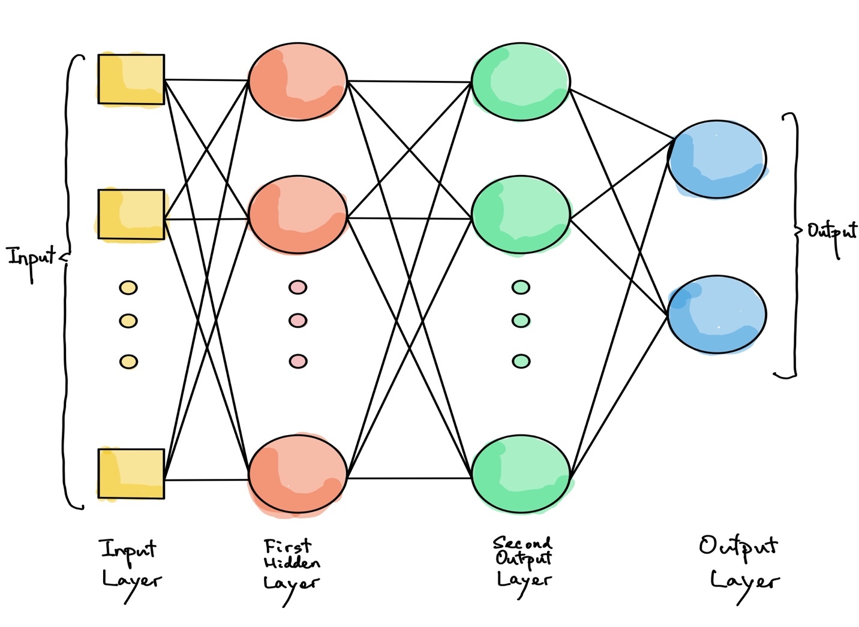

One (passthrough) input layer, one or more hidden layers, and one final layer known as the output layer make up an MLP. Lower layers are those that are closest to the input layer, while upper layers are those that are closest to the output layer. A bias neuron is included in every layer except the output layer and is fully coupled to the following layer (Allan P. 1999).

## **Chapter Summary**

According to the search results, there are some researches were available for individual restaurants open recommendations using supervised data, but no specific topics is covered. Why is ML used in restaurants? To begin, you might be surprised to hear that ML currently assists restaurants in a variety of ways, including:

* More precisely forecasting revenues.
* Detecting employee theft.
* Customer matching to the restaurant based on the taste profile pre-selected.
* Cooking teaching of robots.
* Identification molecular of dietary components.

In this chapter, I present a brief description of ML and describe further ways it might benefit the restaurant business, focusing on two concerns that are also addressed here.

# **CHAPTER 3:**

# **RESEARCH METHODOLOGY**

## **Introduction**

This chapter will provide an overview of the data engine based on the ML model used in this study. The entire process follows the data science lifecycle, from problem formulation to raw data, data engineering, model development, evaluation, and parameter tuning. Finally, the visualization of the results and the implementation of the model.

## **Data Science Analysis / Exploratory Data Analysis (EDA)**

In a work offered the lifecycle of data analysis and development. We often want a numerical prediction over a categorical target. In current Restaurant Status research, a basic yes/no prediction of whether a restaurant is likely to continue for keep the business running may not be sufficient; we want to model the probability that the restaurant will continue. This is still considered classification modeling rather than regression because the underlying target is categorical. The process includes main data from Ambros, From defining the problem to the final product – deployment and insights illustration – the Hong Kong government and property agency took a step by step approach. Understanding the data, selecting relevant tools and approaches, data preparation, constructing a model, testing it, and analyzing the findings are the six primary processes. Each stage has its own set of activities and goals to achieve. The key actions and occupations completed in this project at all phases will be shown in the following subchapters.

(Deanne Larson, Victor Chang, 2016)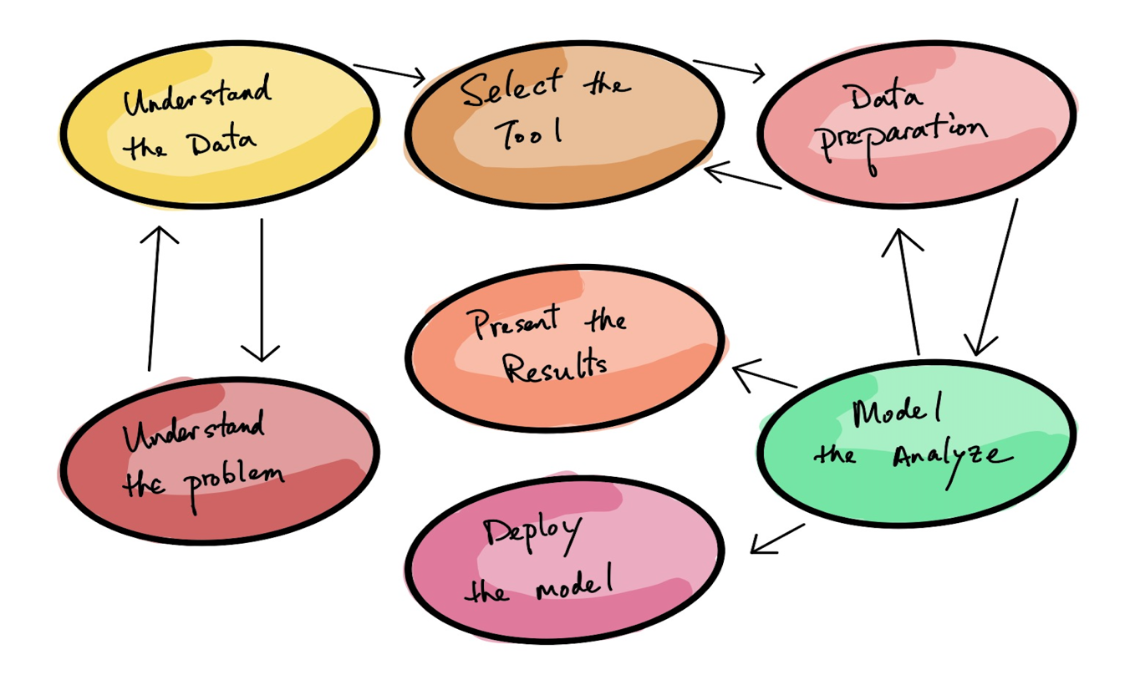

### **Understand the Data / Data Preparation**

The dataset available is containing the information of different restaurants of Hong Kong. The dataset has features based on ages, areas and different type of payments. With all these there were features of total sales and restaurant status. As a result, the data is supervised. Obviously, If Ambros gave us data that are full of null values, outliers and noise, it would be hard to spot the patterns afterwards. It often deserves the effort to purify our data. In fact, all data scientists spend a lot of time doing this.

#### **Handling, cleaning, and preparing data**

* I discovered that some instances are definitely outliers, and it simply discards them or attempts to manually correct the faults.
* I need to decide if I want to disregard this property entirely, ignore certain cases, set missing values (e.g. location or monthly rental price) or train a feature model and one without it, etc…
* Change the name of each restaurant to number and remove or change “Null” value
* There was some bad data because the restaurant type was sometimes not correct. I must change it. For example, if a restaurant name contained [restaurant, fast_food] “restaurant” in it, it was classified as a fast food restaurant but when double check from Openrice.com, it shows the other type.

We then formatted the data in preparation for ML. The following table presents an extract of the formatted data shows in figure 2.

#### **Feature Engineering**

#### I can only learn if there are enough relevant training data and not too many irrelevant variables. In our case, there are a lot of operational data which need to remove, eg. type of food, product type of restaurant, restaurant table number, different time sales revenue etc… A key aspect of the success of an ML project is to develop a good number of features.

#### This technique, known as function engineering, comprises:

* Feature selection: from a list of available features, choose the most beneficial ones to train on.
* Feature extraction is the integration procedure for the creation of a new, better useful functionality.
* By obtaining new data, new functionalities can be created.

#### **Reviewing Ambros’s private data**

The data can be underfitting, It happens when the model is too basic to learn the data structure.

The following are the most important steps in resolving this issue:

#### Choosing a more powerful model that includes more parameters derived from public data. Data from government and property agencies, for example.

#### Increased the number of functions supplied by the learning algorithm - feature engineering.

#### Reduce the limitations of the model - by lowering the regularization hyper parameter.

#### Using a 0 or 1 to indicate if the establishment is “Open” or “Closed”

#### **So the next 7 Steps model development is**

1. Take a broad view of the private and public data.

2. Combine all personal and public information.

3. Gain information from Ambros, the government, and the property agent by discovering and visualizing both.

4. Learning from the data by fitting a model to it.

5. Choosing and designing features

6. Using cross-validation, choose a model and tune hyperparameters.

7. Present my solution.

### **Frame the Problem**

The first question to examine is what the business aim is; developing a model is unlikely to be the ultimate goal. What are the Ambros' plans for using and benefiting from the models? This is significant because it will influence how we define the problem, the methods we use, the performance metric we use to evaluate our model, and the amount of time we spend tweaking it. The second question to consider is how the existing solution seems (if any). It often gives us a reference and suggestions for solving the problem, and we are ready to start creating our code using this information. Initially, the problem has to be monitored, unattended or strengthened learning. Is it a classification, regression or a whole other thing? Do we have ways of learning in batch or online?

The main problem is to predict whether the location will be appropriate for opening a restaurant or not. Also, the main problem is the predict the total sales predictions of different restaurants.

Choose a metric for measuring performance.

The following step is to choose a performance metric. The Root Mean Square Error is a common performance indicator for regression situations (RMSE). It indicates how much inaccuracy the code generates in its predictions on a regular basis, with larger errors having a higher weight.

Root Mean Square Error (RMSE)

RMSE(X,h) = $\sqrt{\frac{1}{m}}$ ${(h\left(x^{\left(i\right)}\right)-y^{\left(i\right)})}^{2}$

### **Select the Tool**

#### There are a variety of programming languages and interfaces that may be used to create ML algorithms to distinguish between regular and attack source packets. Python is one of the most extensively used languages for this purpose. Jupyter Notebook, often known as Google Colab, is an interactive interface that makes flow more engaging and intelligible.

#### **Prerequisites**

This research means that we have some competence in Python programming and knowledge of the main science libraries in Python, in particular, NumPy, Panas and Matplotlib. Additionally, knowledge of (calculus, linear algebra, probability, and statistics) as well as Python (http://learnpython.org/) is required.

#### **Python Programming Language:**

Python programming soon becomes one of the most famous logical processing dialects. Python's simplicity has enticed many developers to create new ML packages, resulting in widespread Python usage. I'll be utilizing the following production-ready Python frameworks:

Here is a brief summary of each of our packages:

**NumPy:** Provides support for large, multidimensional arrays as well as an extensive col‐ lection of mathematical functions.

**Pandas:** A data processing and analysis library. It includes, among other things, data structures for dealing with tables as well as tools for manipulating them.

**Matplotlib:** A plotting library that allows the creation of 2D charts and plots.

**SciPy:** SciPy is a Python package that combines NumPy, Pandas, and Matplotlib. SciPy is a Python library ecosystem for math, science, and engineering.

**Scikit-learn (or sklearn):** A ML library that includes a variety of algorithms and tools. It's simple to use, yet it efficiently implements several ML techniques, making it an excellent starting place for learning ML.

**Keras:** A library for artificial neural networks that can be used as a simple interface to the TensorFlow/Theano packages. It's a high-level Deep Learning API which makes neural networks easy to train and run.

**Seaborn:** A Matplotlib-based data visualization package. It has a high-level interface for creating visually appealing and instructive statistics visuals.

**PIP and Conda:** Python package managers are the tools that allow you to install Python packages. pip is a package manager for Python that makes it easy to install, upgrade, and uninstall packages. Conda is a Python package manager that also manages library dependencies.

**Steps for Model Development in Python Ecosyste*m:***

It's crucial to work through ML difficulties from beginning to conclusion.

The diagram below depicts a simple seven-step ML project template that may be used to kick-start any Python ML model. The first few steps include exploratory data analysis and data preparation, which are typical data science based steps aimed at extracting meaning and insights from data. These steps are followed by model evaluation, fine-tuning, and finalizing the model.

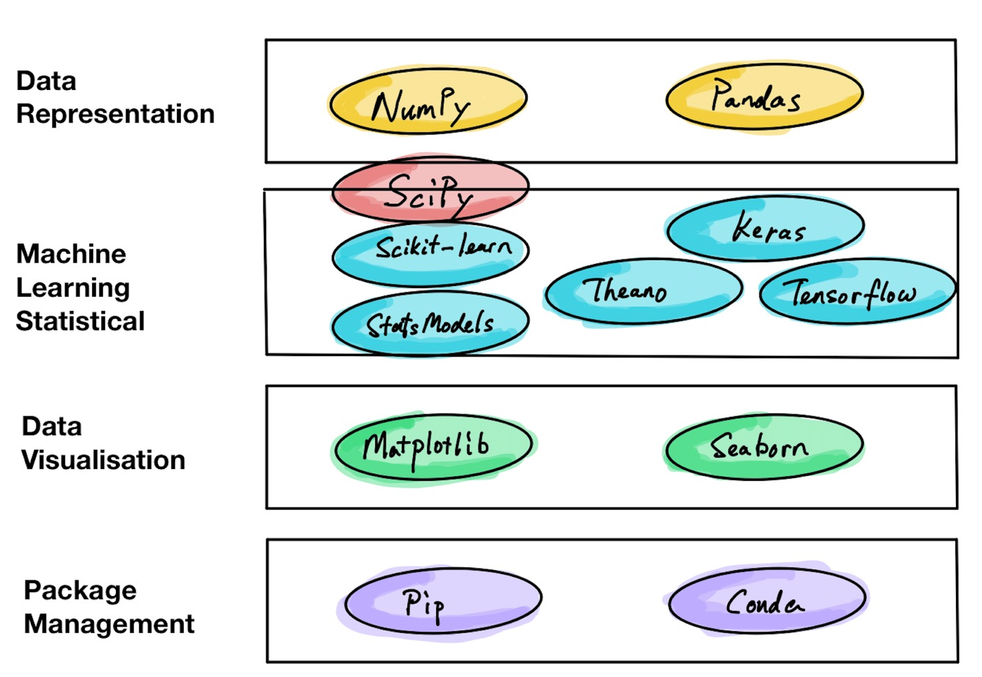

Diagram above. Model development steps

In our case, follow the standard seven-step model development process, renamed, or reordered based on the appropriateness and intuitiveness of the steps. The following section covers the details of each model development step with supporting Python code.

Problem definition

The first step is defining our problem – 1 and 2 . Select or some powerful algorithms can be used for solving the problem, but the results will be meaningless if the wrong problem is solved.

### **Data Preparation**

Data was prepared for train and test while selecting the important features using human intelligence. These features were important as they all were helping in basis of Restaurant Open and Sales.

### **Model Analyze**

Models were analyzed using accuracy and confusion matrix and confusion report for classification matrix and mean squared errors for the regression models.

### **Present the Results**

The results were presented using plotly library. The accuracy for all classification models were printed together to show the best model. The mean squared error for all regression algorithms was plotted together to get the best algorithm with lowest error.

### **Deploy the Model**

The best models for both cases were then passes through the K Fold Cross Validation Techniques for their final selections.

## **Methodology**

The components of the ML pipeline in this example included problem formulation, data planning, feature design, model training, model evaluation and post-hoc analysis. Prior to beginning, all required libraries must be imported, the random seed set to a fixed value and our workplace organized. The project was also implemented in python program and it’s a sequence of code and running it randomly may cause the error as the coding is a step-by-step process. So, it is important to consider this while running the code.

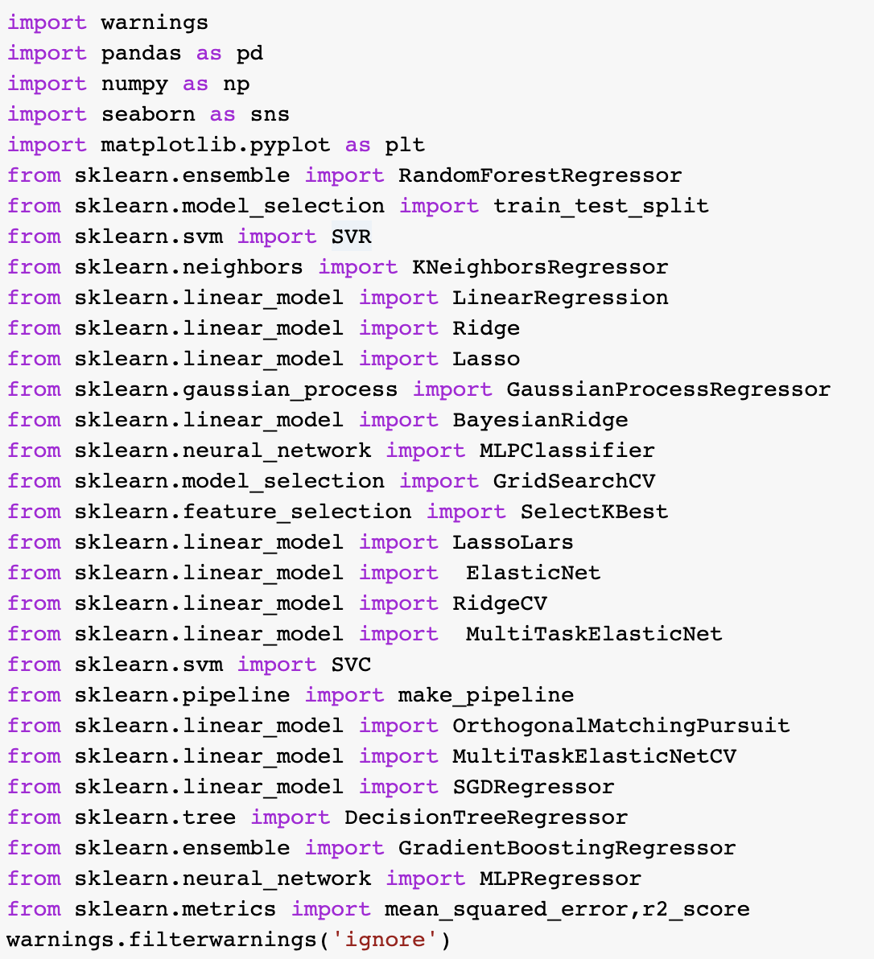

Figure 1: Importing Libraries

The libraries are discussed in previous sections were imported at the first place. Warnings are used to avoid any warning that may occur during coding process.

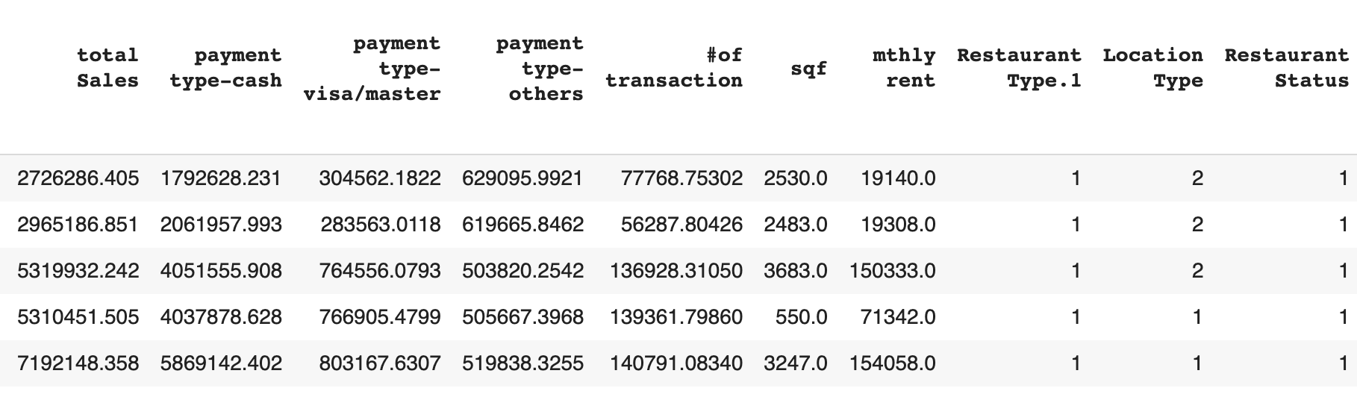

Figure 2: Reading the dataset

The dataset was read using the pandas read csv method. The target attribute's value is known. Because the target is a category (yes or no) for Restaurant Status, which I adjusted to 1 = yes, 0 = no when I completed the data mining, it's a classification challenge.

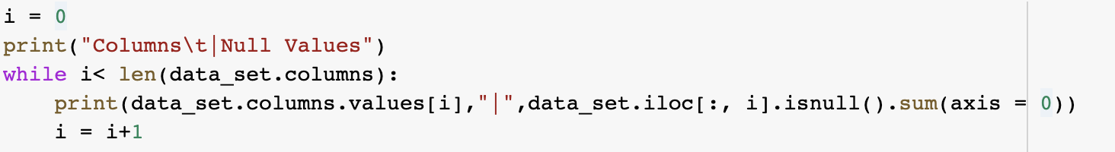

Figure 3: Checking Null Values in each column

Null values for each column were checked using the code in figure 3.

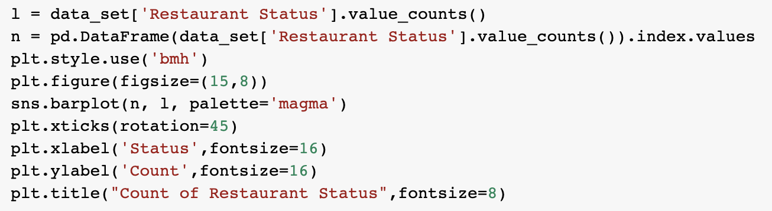

Figure 4: Viewing the overall status

For checking how much data of Restaurant status were available the value counts for both open and close was done.

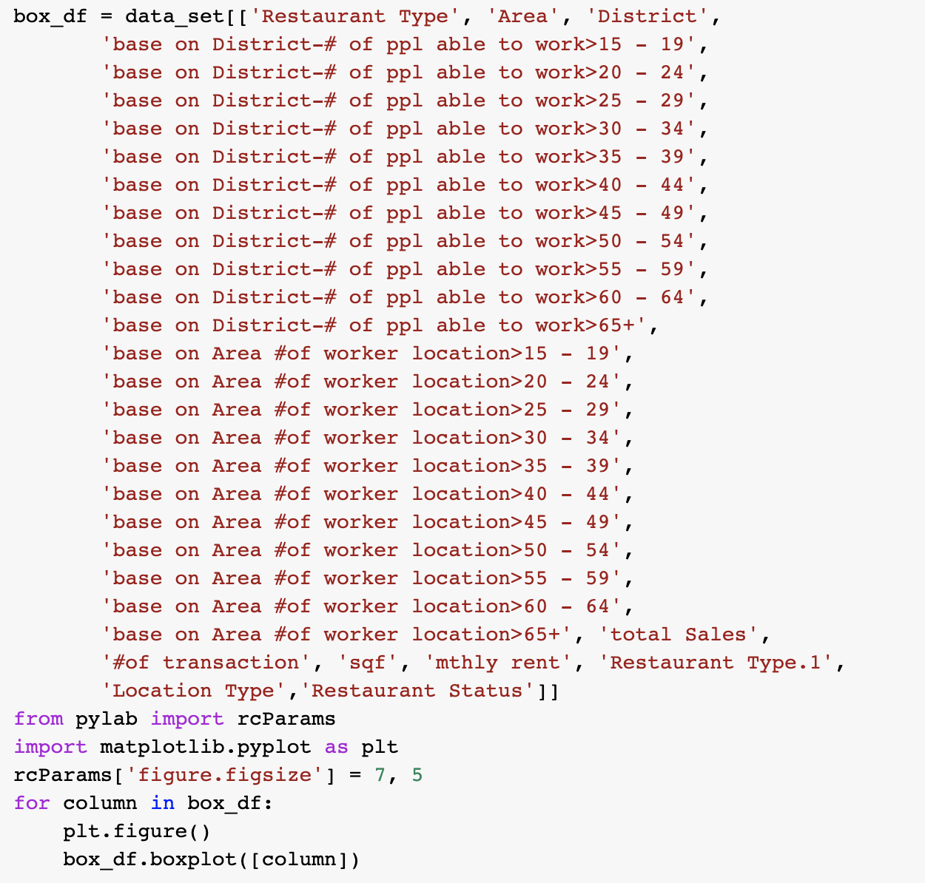

Figure 5: Code for Boxplot

Boxplot code is used to get insights of each feature that will help for overall status of the data from business point of view.

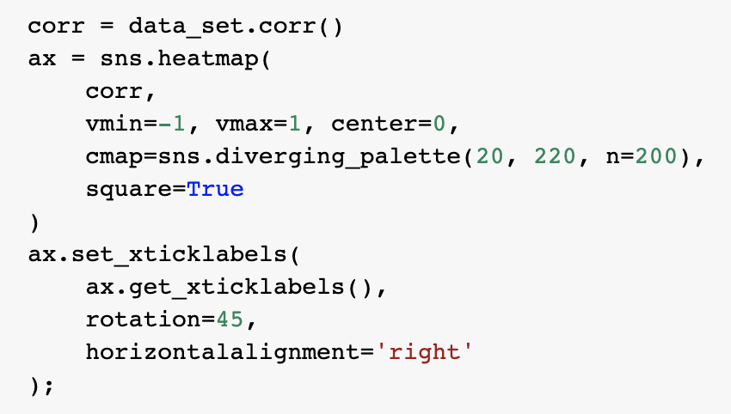

Figure 6: Co relation between variables

The co relation between all variables was checked and plotted using the above code.

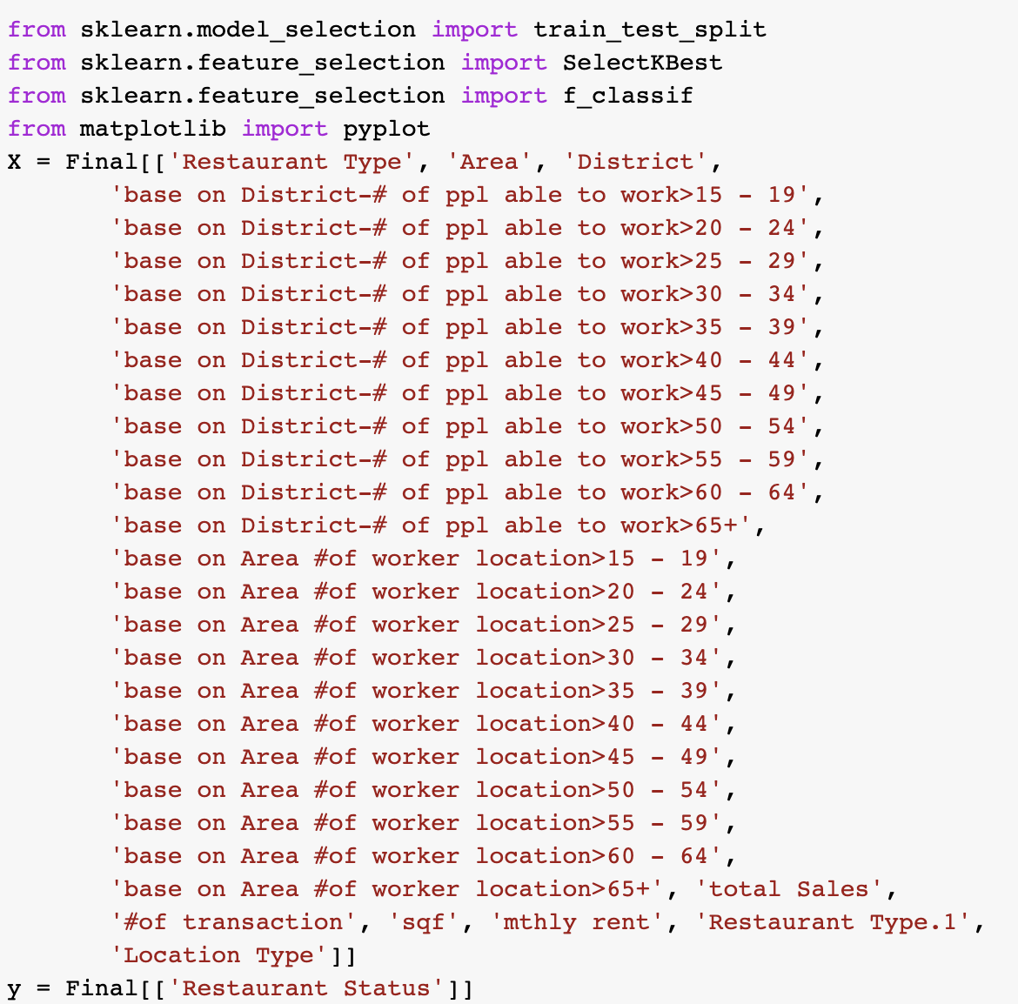

Figure 7: Selection of X and Y for classification algorithm

First step was to use the Classification Algorithms to predict the restaurant stats. In figure 7 the target and the inputs were splitter into X and y.



Figure 8: Train and test splitting the data

33 % of the data was chosen as the test size to get the maximum accuracy in future.

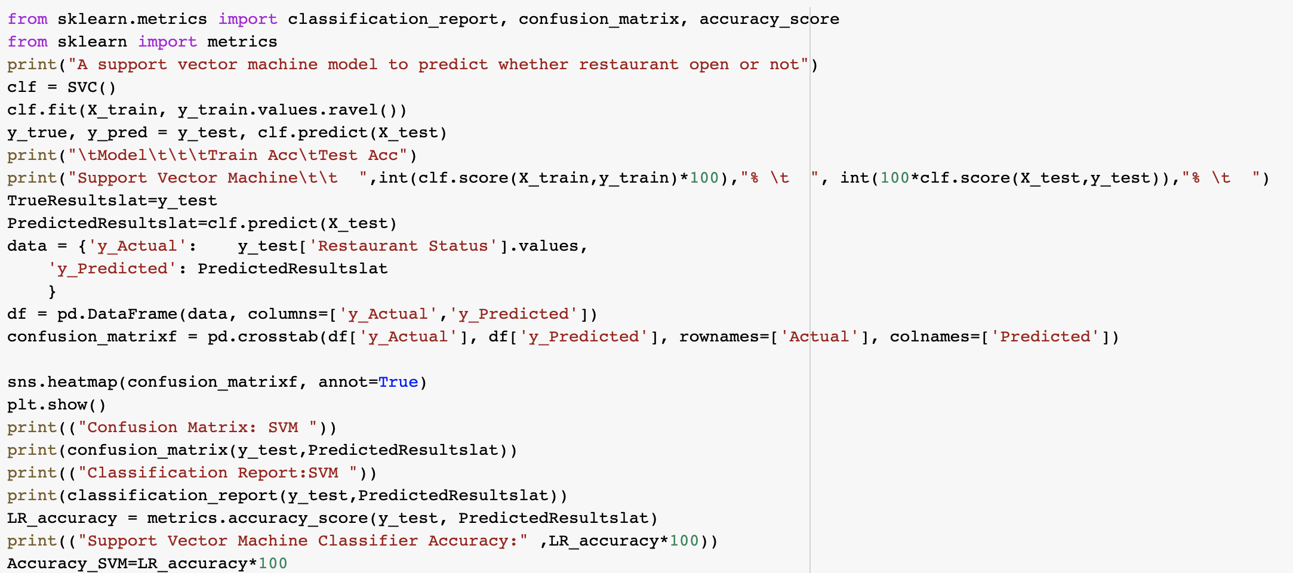

Figure 9: Support vector machine for restaurant status Prediction

The above code is showing the implementation of ML Algorithms for restaurant predictions.

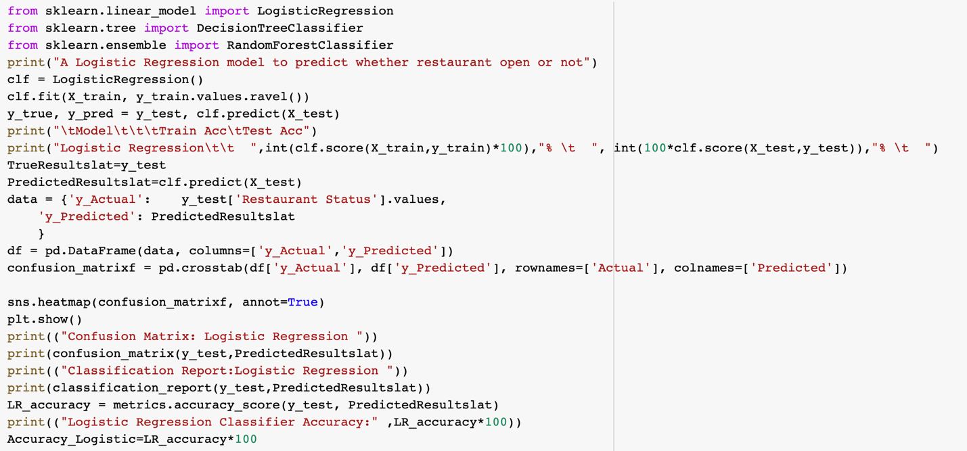

Figure 10: Logistic Regression for restaurant status Prediction

The above algorithm is showing the implementation of Logistics Regression for the restaurant status prediction.

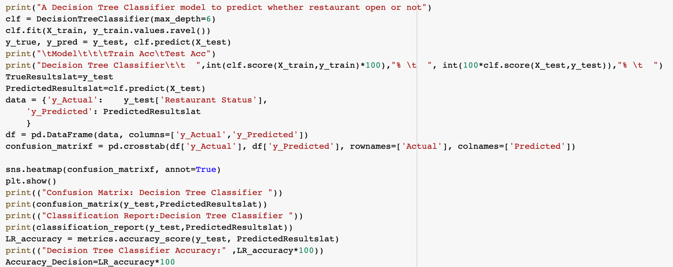

Figure 11: Decision tree Classifier for restaurant status prediction

The above code is showing the implementation of Decision Tree Classification for the restaurant status prediction.

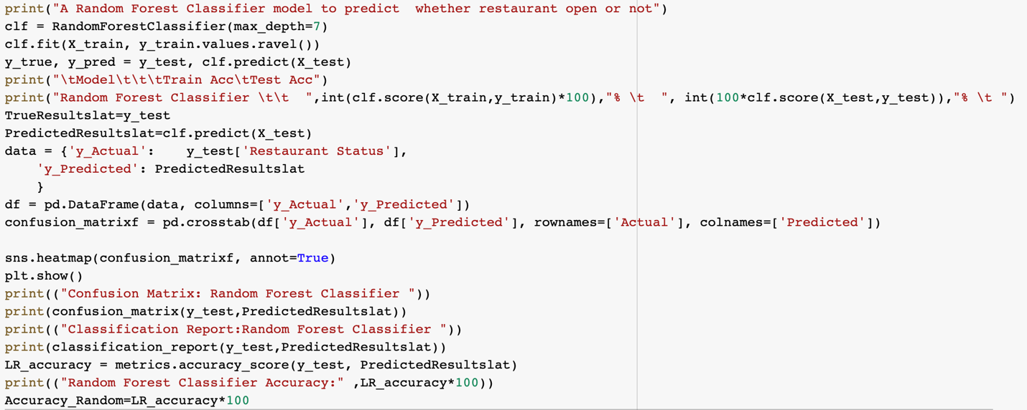

Figure 12: Random Forest Classifier for restaurant status prediction

The above code is showing the implementation of Random Forest Classification for the restaurant status prediction.

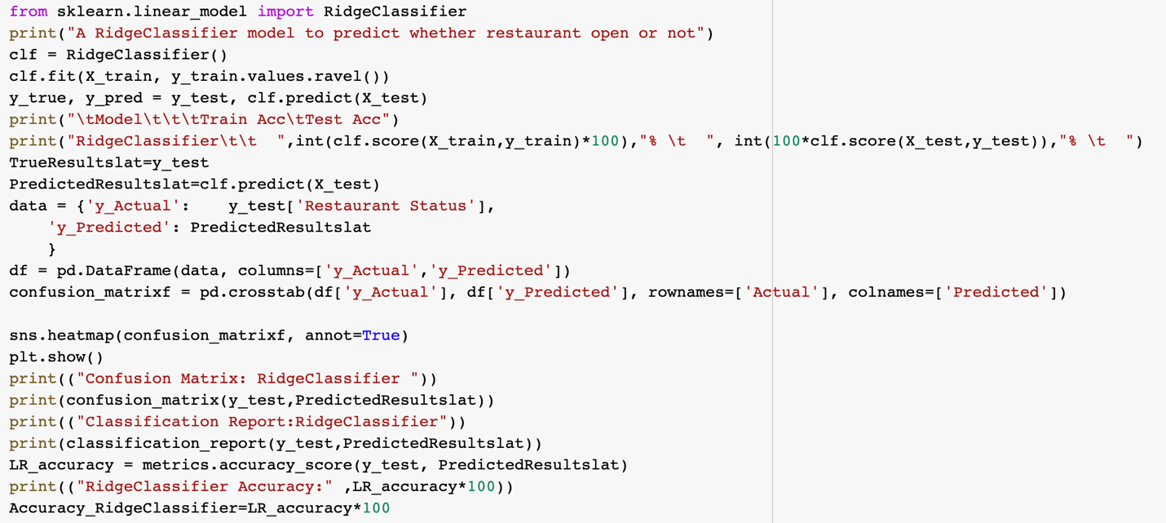

Figure 13: Ridge Classifier for restaurant status prediction

The above code is showing the implementation of Ridge Classification for the restaurant status prediction.

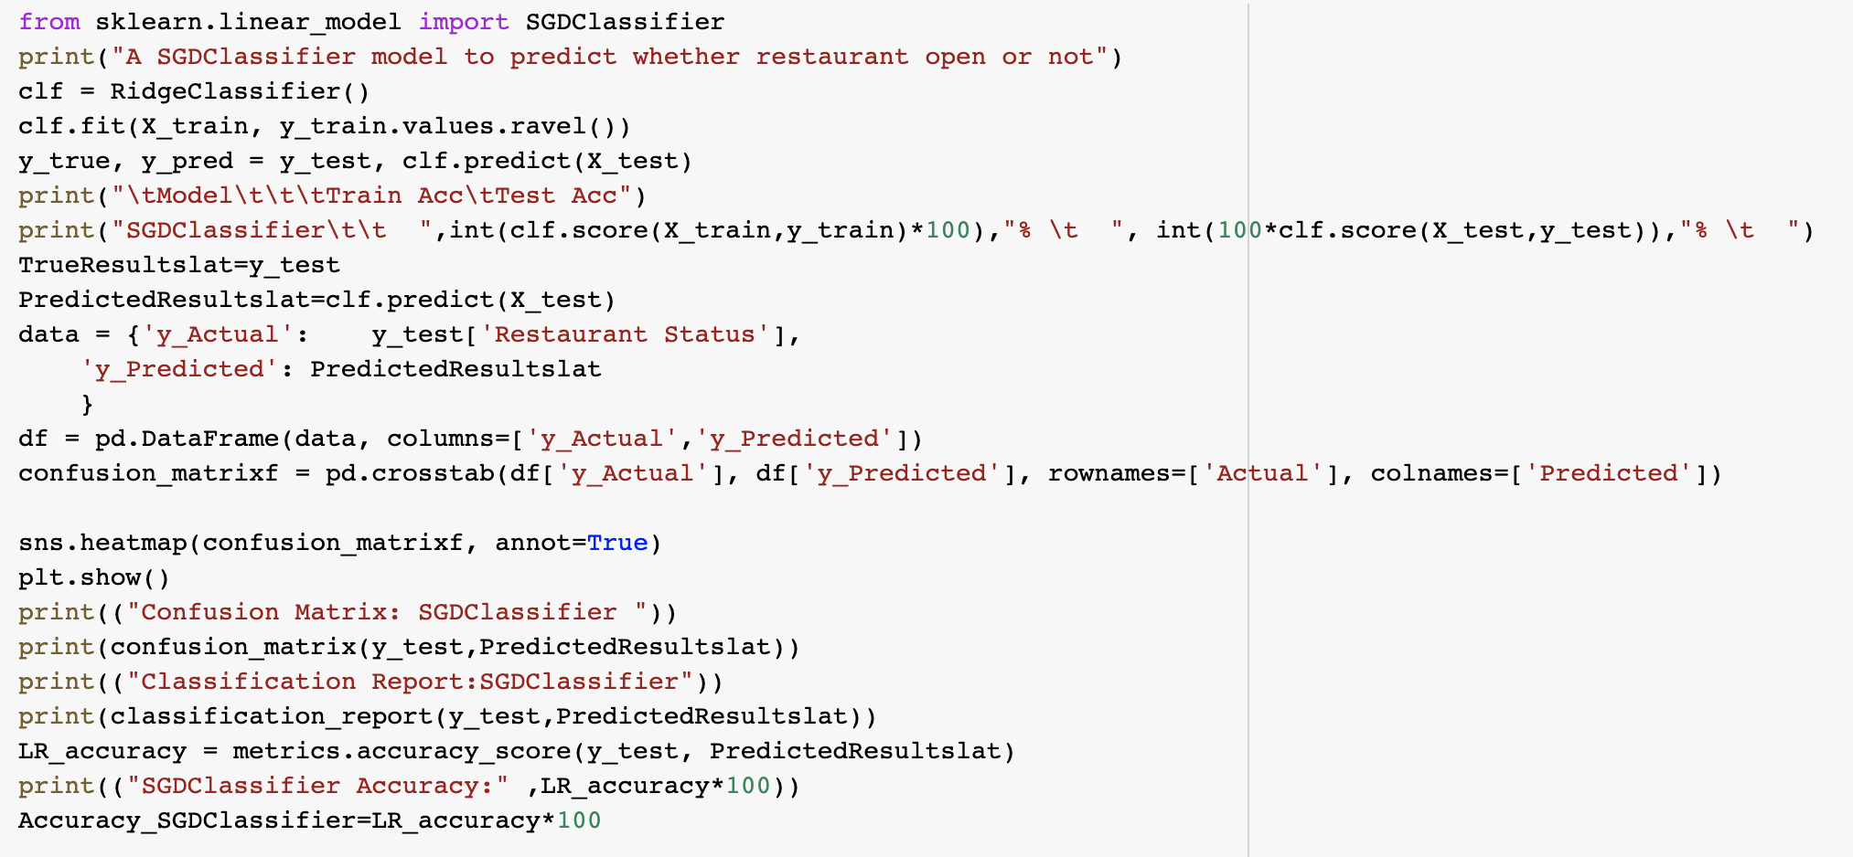

Figure 14: SGD Classifier for restaurant status prediction

The above code is showing the implementation of Stochastic Gradient Descent Classification for the restaurant status prediction.

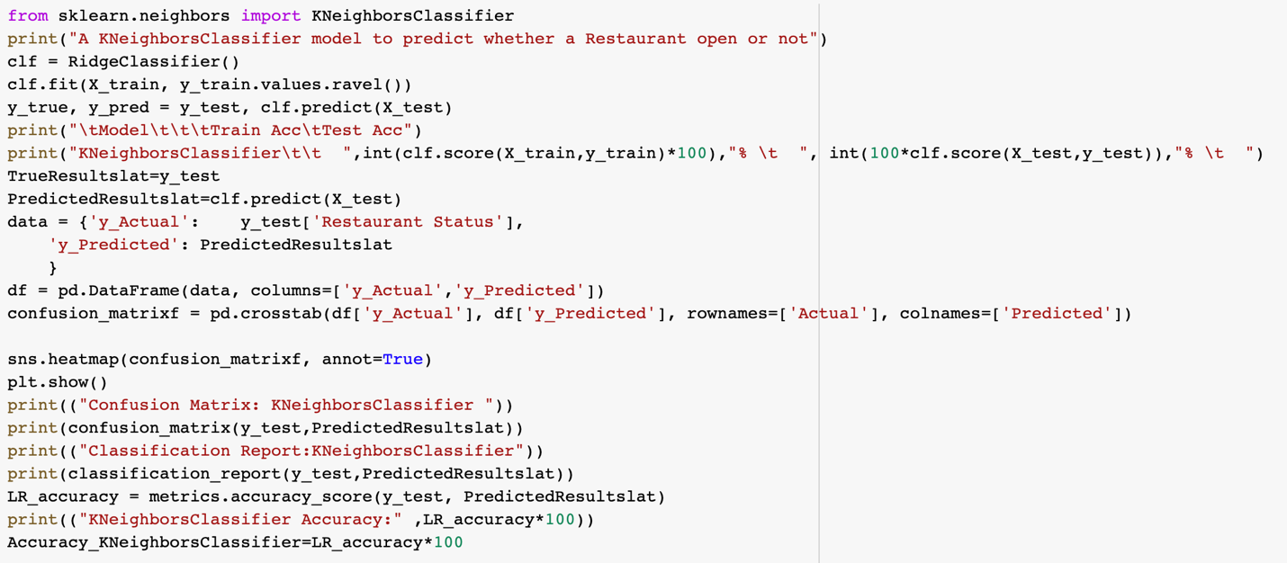

Figure 15: K Neighbor Classifier for restaurant status prediction

The above code is showing the implementation of K Neighbor Classification for the restaurant status prediction.

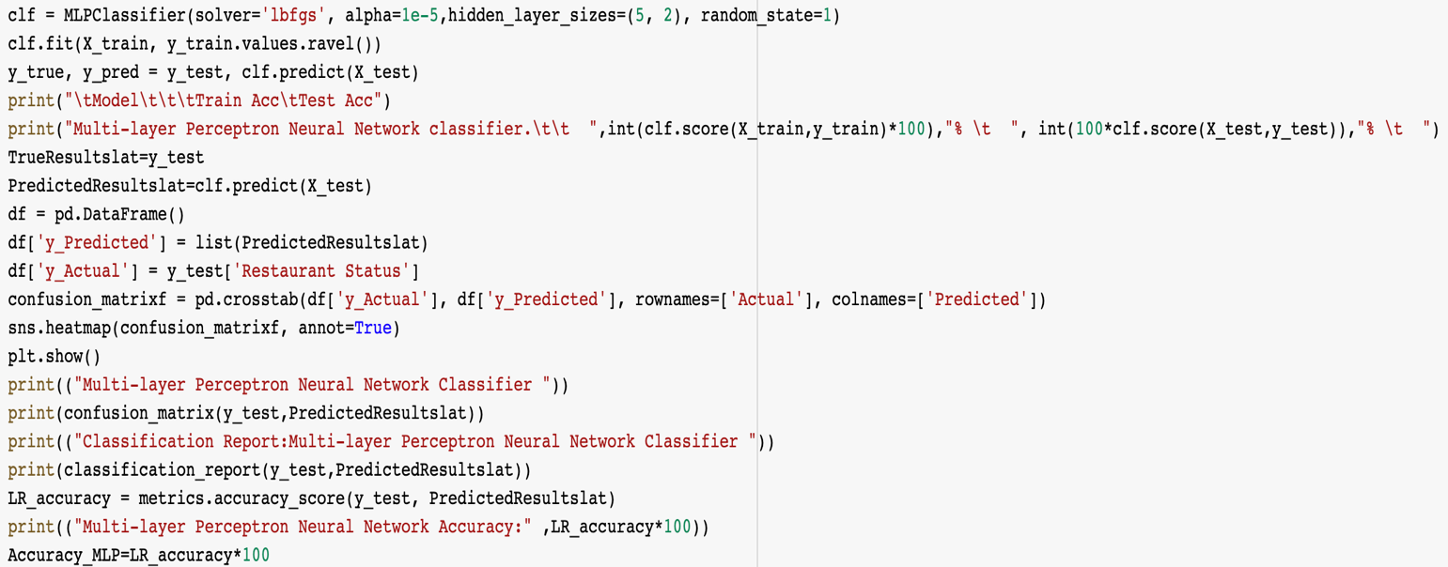

Figure 16: Multi-layer perception neural network for restaurant status prediction

The above code is showing the implementation of MLP on for the restaurant status prediction.

**Neural Network**

For the Neural Network, we utilized the Keras library. I start with a Sequential model and gradually build layers.

The first thing we do is make sure the input layer has enough input features. This is indicated by setting the **input_dim** option to 8 for the 8 input variables when establishing the first layer.

To capture the problem structure, I will need a vast network. We use a completely integrated network structure of three layers. The dense class is used for defining layers which are entirely connected. The first argument is the number of neurons or nodes in the layer, and the second argument is the activation function. We use the linear unit activation function of ReLU in the first two layers and use the Sigmoid function in the output layer.

Once the recommended activation functions for all layers were Sigmoid and Tanh. We were able to attain superior outcomes using the ReLU activation function. By default 0.5, we use a sigmoid on the output layer to provide an easy transition from our network output between 0 and 1 to either a probability of class 1.

By adding each layer, I piece it all together:

* The dim=8 input option indicates that the template expects data rows with eight variables.
* The first hidden layer has twelve nodes and uses relu.
* The second hidden layer, which consists of eight nodes, uses the ReLU activation function.
* In the output layer, the sigmoid activation function is utilized, containing only one node.
* The form of the input model is defined as an argument on the first hidden layer.. This signifies the code line that adds the first layer of dense to define the input or the first layer of hidden layer..

The template is compiled using efficient digital libraries such as Theano or TensorFlow (the so-called backend). The backend picks the correct way to show or even spread the network for hardware training and prediction such as CPU or GPU. During training for network assembling, I define certain additional features needed. The training of the network includes finding the proper weight set for translating inputs into outputs.

The optimizer is used to look for different network weights and any optional measurements that I would like to collect and report in training. I specify the loss feature to be used for weight assessment, and the optimizer is used to search the network's weights and any optional metrics to be collected and reported during the training.

As a **loss** argument, I employ cross entropy. This loss is known as “**binary_crossentropy**” in Keras and is used to solve binary classification issues.

The **optimizer** is defined as the “**adam**” efficient stochastic gradient descent algorithm. Because it automatically tunes itself and produces good results in a wide range of problems, this is a popular variation of gradient descent.

We gather and report the categorization accuracy, which is defined by the **metric** argument. I define and compile our model readily for efficient calculation and run the model on some data, then use a **fit()** function on the model to train or fit our model to our loaded data. Training takes place through time and every era is divided into lots.

* **Epoch**: One pass through all of the rows in the training dataset.
* **Batch**: One or more samples considered by the model within an epoch before weights are updated.

One epoch is comprised of one or more batches, based on the chosen batch size and the model is fit for many epochs. For more on the difference between epochs and batches, see the post:

The training process run for a fixed number of iterations through the dataset called epochs, that we specify using the **epochs** argument. We also set the number of dataset rows that are considered before the model weights are updated within each epoch, called the batch size and set using the **batch_size** argument.

For this problem, we run for a small number of epochs (150) and use a relatively small batch size of 10.

I want to train the model enough so that it learns a good (or good enough) mapping of rows of input data to the output classification. The model always has some error, but the amount of error level out after some point for a given model configuration. This is called model convergence.

I have trained our train neural network and analyze the network's test data set performance. On the basis of the assessment function () of our model, we evaluate our model on our test set and pass it the identical input and output used for model training. This generates an output forecast for every input and output pair, including the average loss and any measurements, such as accuracy, that we have set up.

The **evaluate()** function returns a list of two values. The first is the loss of the data set model, and the second is the accuracy of the dataset model. We simply want to report the precision, hence we ignore the value of the loss.

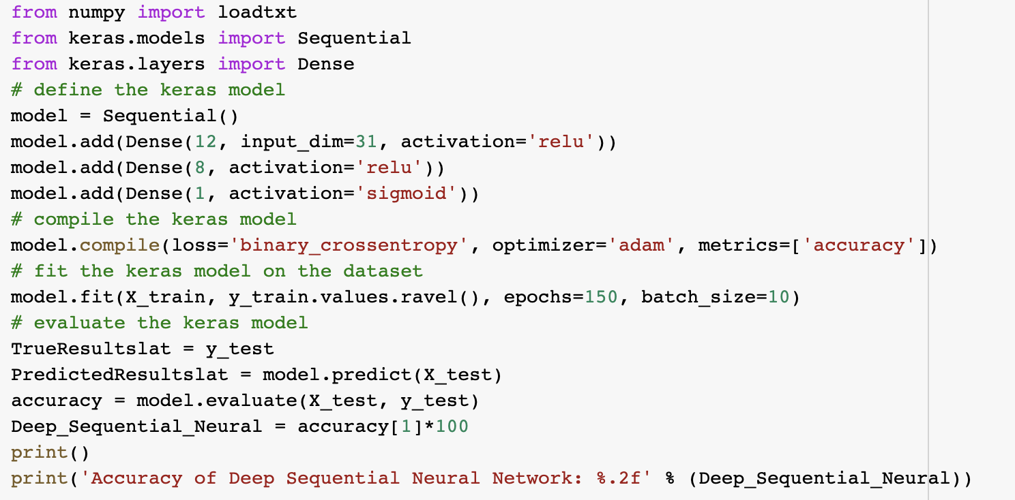

Figure 17: Deep Sequential neural network for restaurant status prediction

The above code is showing the implementation of deep sequential neural network classifier for the restaurant status prediction.

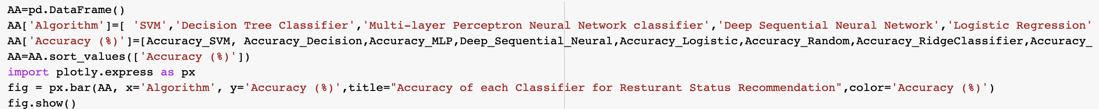

Figure 18: Combined Plot for accuracy of each classifier

Figure 18 is the code for combined plot for each Classifier.

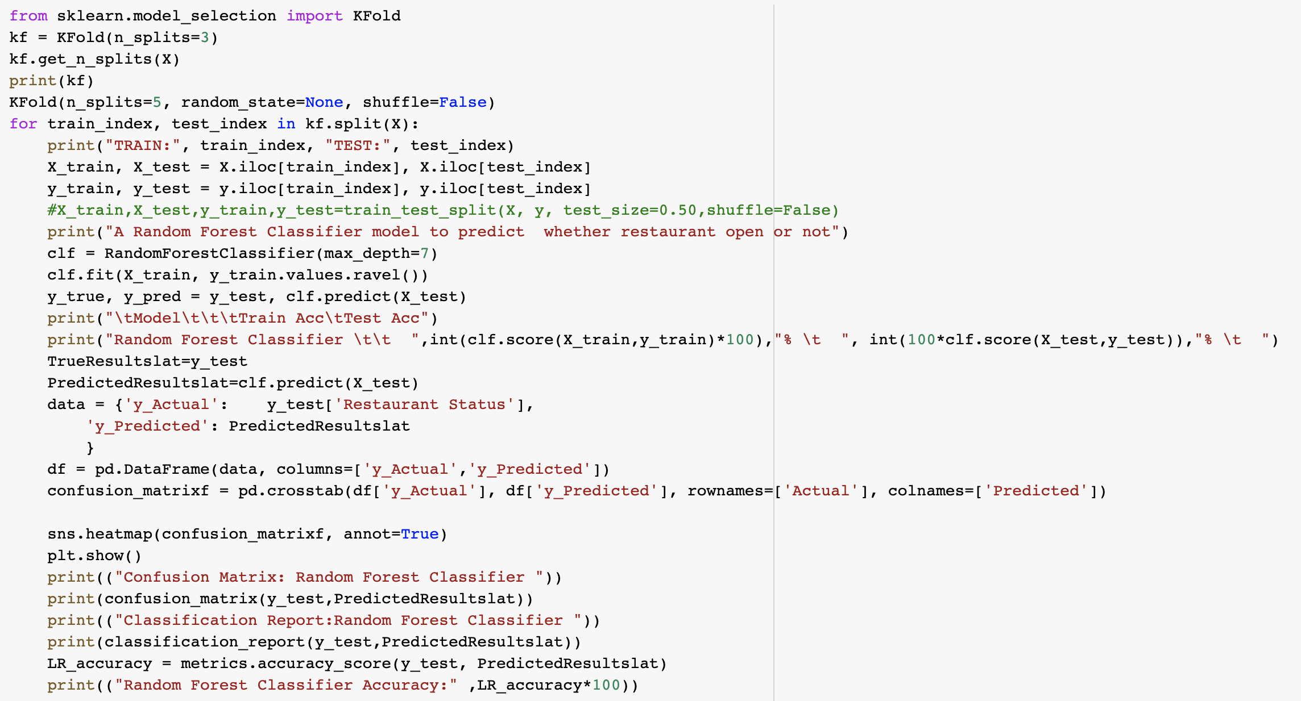

Figure 19: K-fold cross validation on random forest

From visualizations it was checked that Random Forest Classification is the best algorithm for this project. So, K Fold cross validation is done using sklearn K Fold Model.

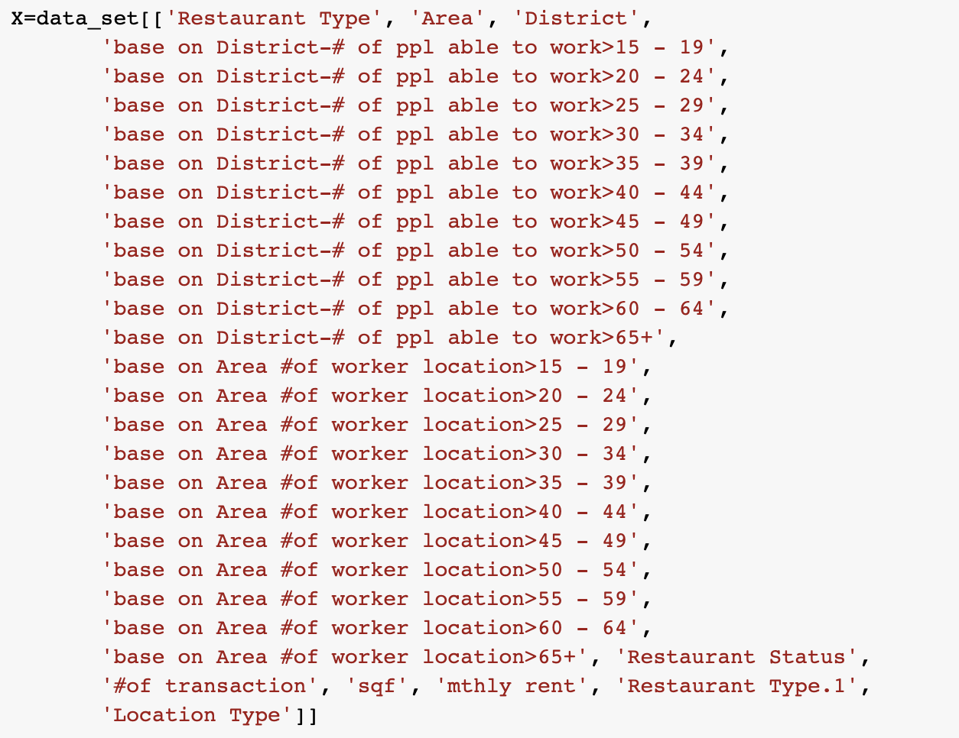

Figure 20: Selection of Variables for Regression Algorithms

The above code is showing the variable selection for the total sales prediction.



Figure 21: Train Test split on regression algorithms

The above code is showing the train and test splits of each algorithm.

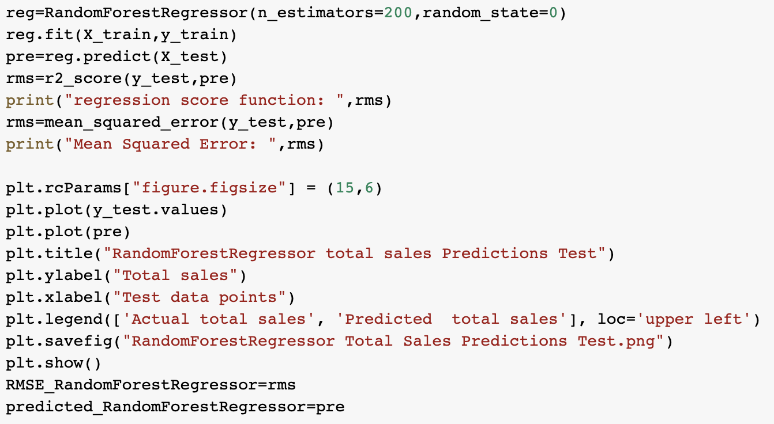

Figure 22: Random forest regression for total sales prediction

The above code is showing the implementation of Random Forest Regression for total sales prediction.

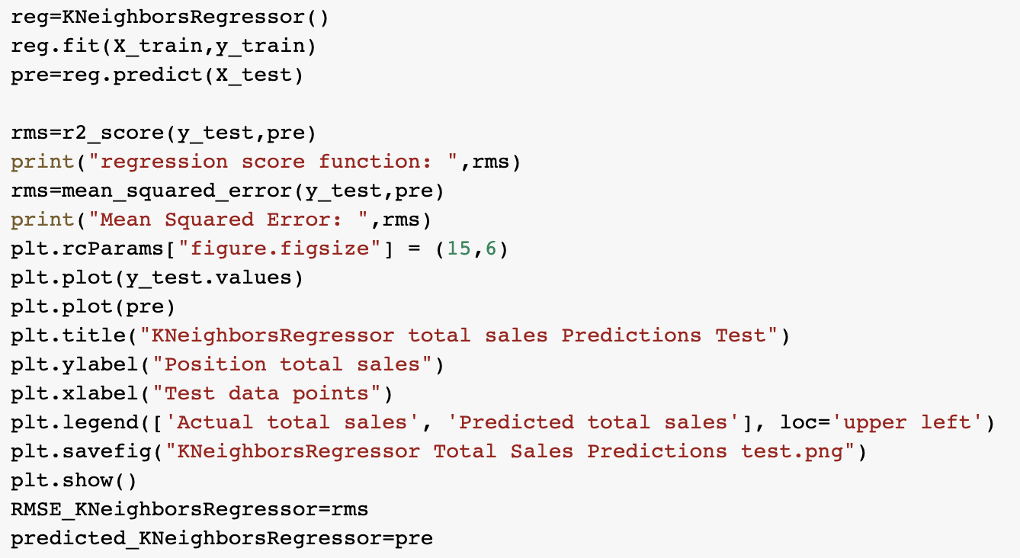

Figure 23: K Neighbor Regression for total sales Prediction

The above code is showing the implementation of K Neighbor Regression for total sales predcition.

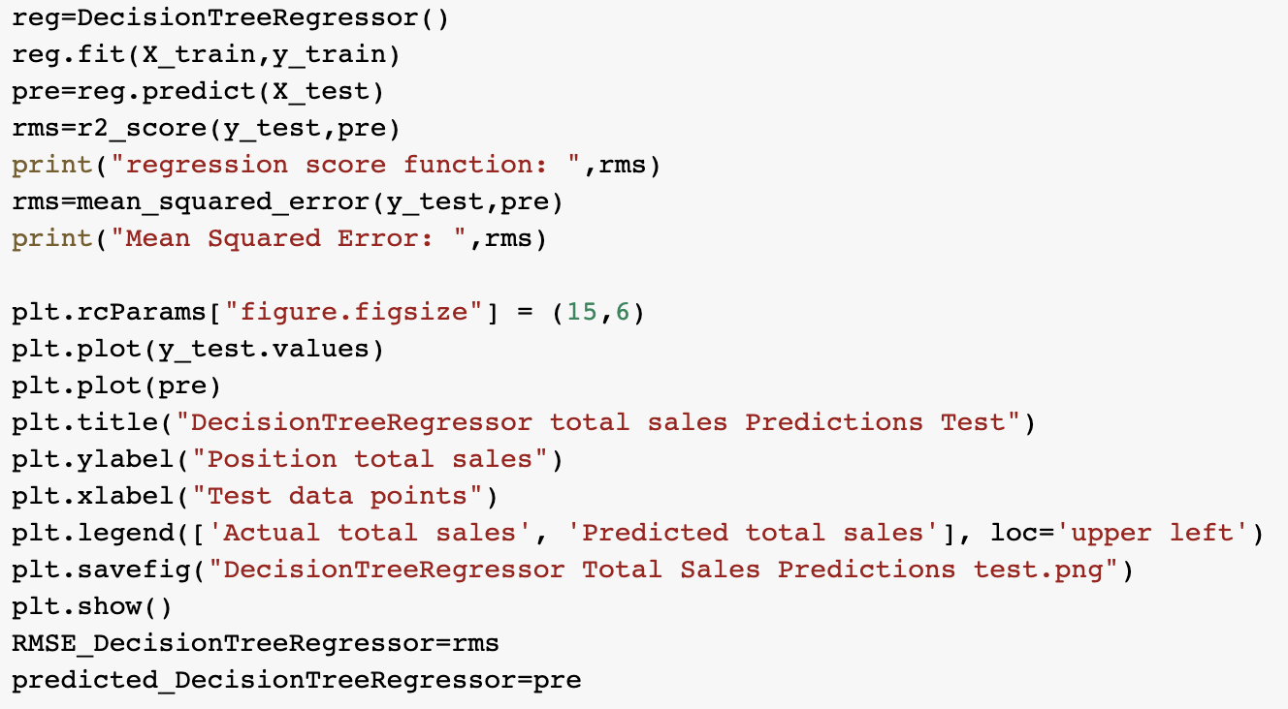

Figure 24: Decision Tree Regression for Total sales prediction

The above code is showing the implementation of Decision Tree Regression for total sales prediction.

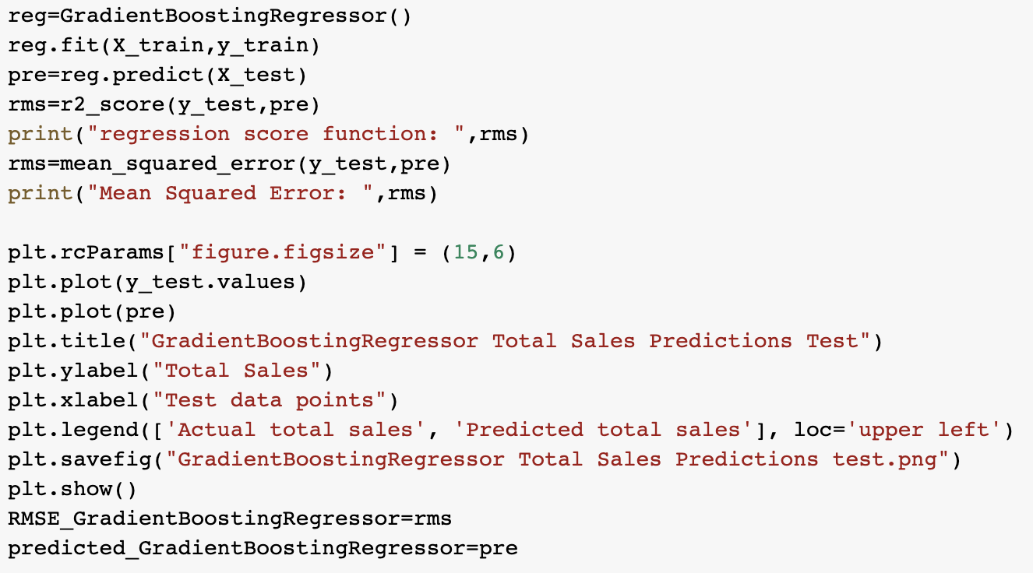

Figure 25: Gradient Boosting Regression for Total Sales Predictions

The above code is showing the implementation of Gradient Boosting Regression for total sales prediction.

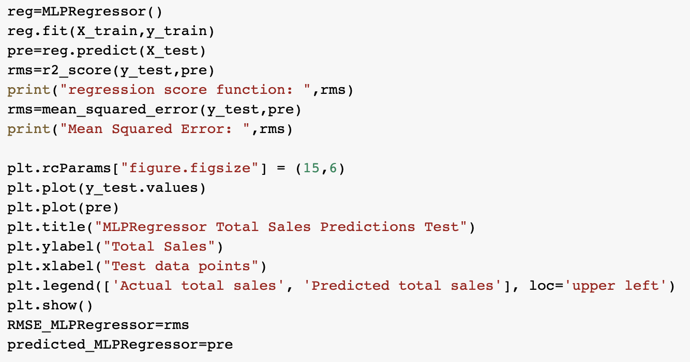

Figure 26: MLP Regression for total sales prediction

The above code is showing the implementation of MLP Regression for total sales prediction.

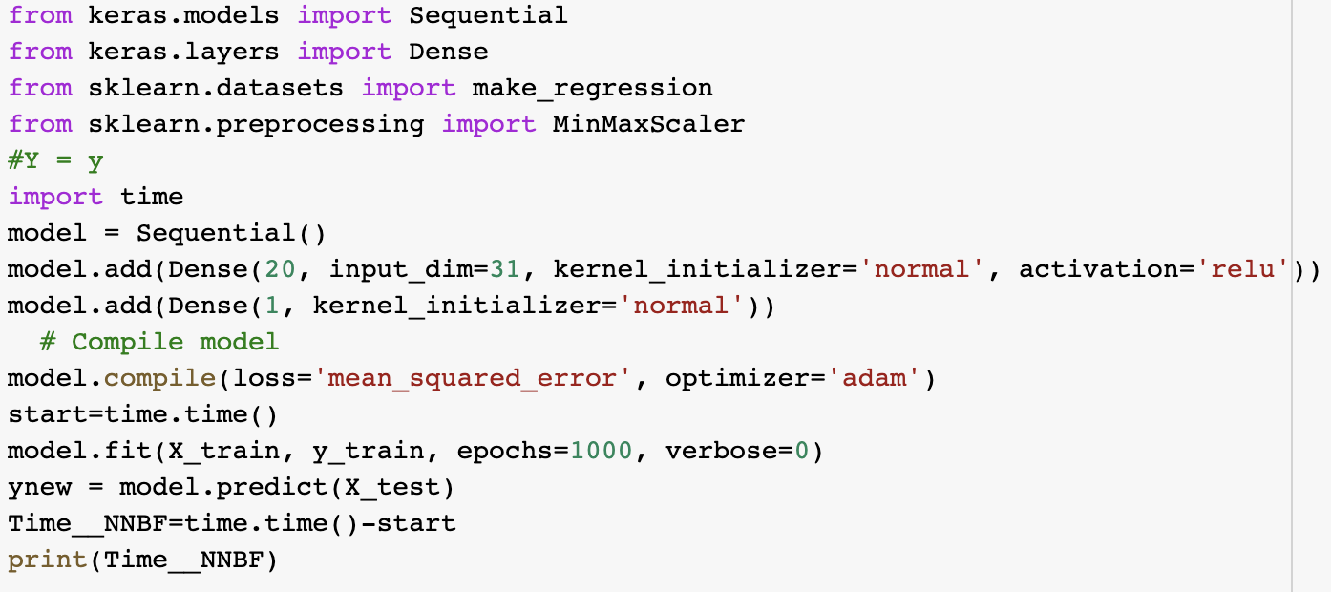

Figure 27: Neural Networks for total sales predictions

The above code is showing the implementation of Deep Sequential Neural Network Regression for total sales prediction.

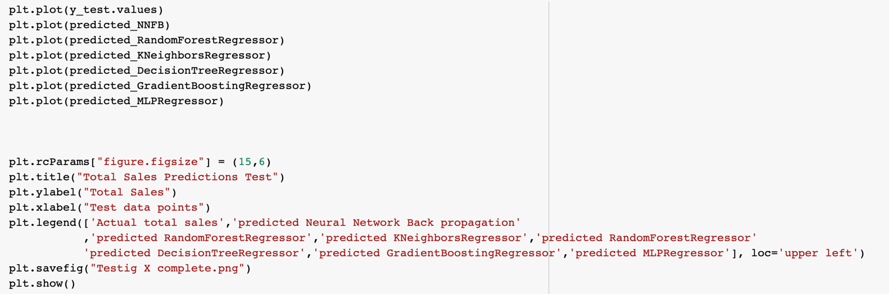

Figure 28: Code for combined plot of original and predicted total sales for all algorithms

The above code is showing the combined plot for each algorithm.

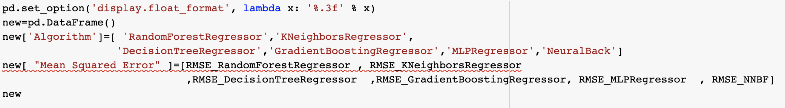

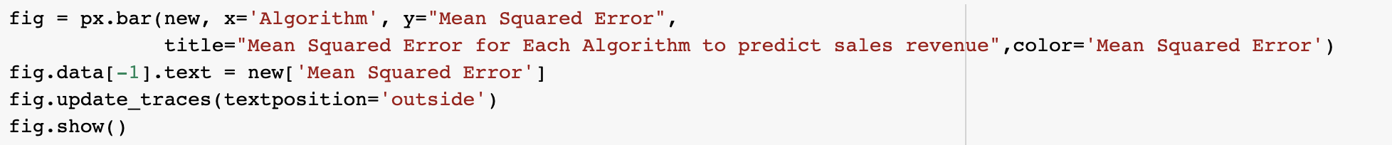

Figure 29: Code for combined mean square error plot for regression algorithms

The combined plot for mean squared error for each algorithm was plotted using this code.

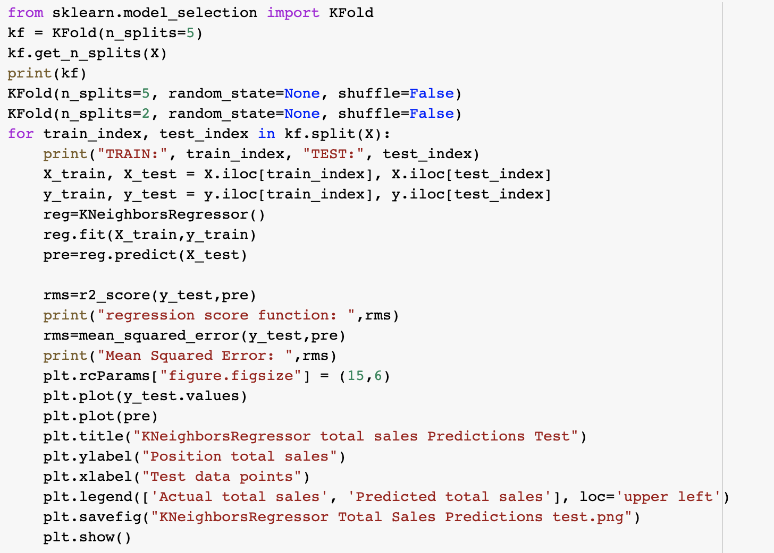

Figure 30: Cross Validation for K Neighbor Regression for total sales prediction

The last step I methodology was to apply cross validation techniques.

## **The Evaluation Methods**

Accuracy Measures techniques used for Classification

- Mainly 4 techniques are used

#### Precision

Precision talks about how precise/accurate our model is out of those predicted positive, how many of them are actual positive. Precision is a good measure to determine, when the costs of False Positive is high.

#### Recall

Recall shall be the model metric we use to select our best model when there is a high cost associated with False Negative.

#### F1- Score

F1 Score might be a better measure to use if we need to seek a balance between Precision and Recall AND there is an uneven class distribution (large number of Actual Negatives).

#### Accuracy

Accuracy shows the combined effect of the precision and recall when both factors are important

Since it is important to know which factors will affect restaurant open and what factors do not, we focused on combined accuracy for the final purpose.

Accuracy Measures techniques used for Regression

#### Mean Squared Error

For accuracy measurement of regression algorithms mean squared error was calculated.

## **Chapter Summary**

This chapter has explained the methodology of this research, the development from problem statements to model building and evaluation. Also, this development plan is consistent with data product development lifecycle. I also talked about the various error measures that can be used to evaluate a model. In addition, I discussed the various steps involved in using ML algorithms to solve a business problem. Especially the neural networks model produces different results compared to ML model. The next chapter will be discussed about the model results.

# **CHAPTER 4:**

# **DATA ANALYTICAL RESULTS & EVALUATIONS**

## **Data analytical results**

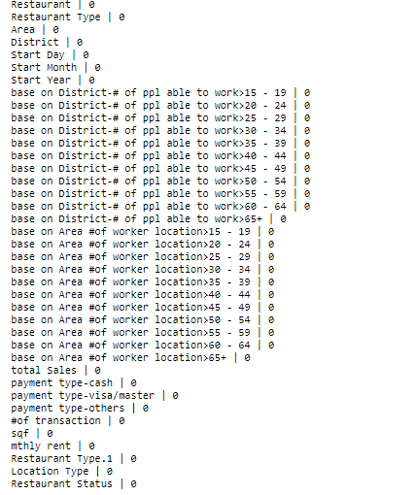

Figure 31: Null Values of each columns

Figure 31 is showing that there is no null value in the dataset.

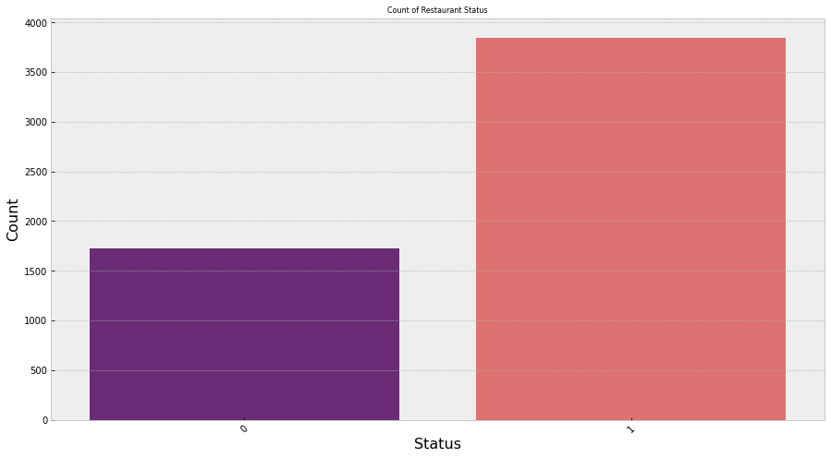

Figure 32: Count of Restaurant Status

Figure 30 is showing that Almost more then 1500 restaurants were not open, but more than 3500 restaurants were open.

Boxplot for distributions of each feature

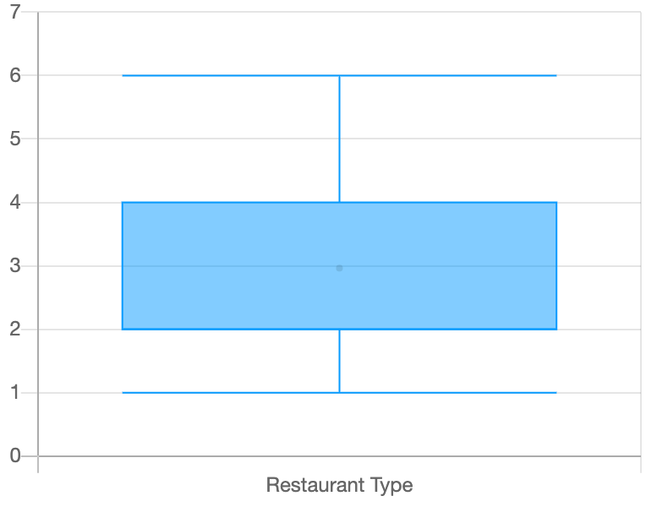

Figure 33 Boxplot visualization for restaurant type

It can be seen that mostly data belongs to first 4 types of restaurants.

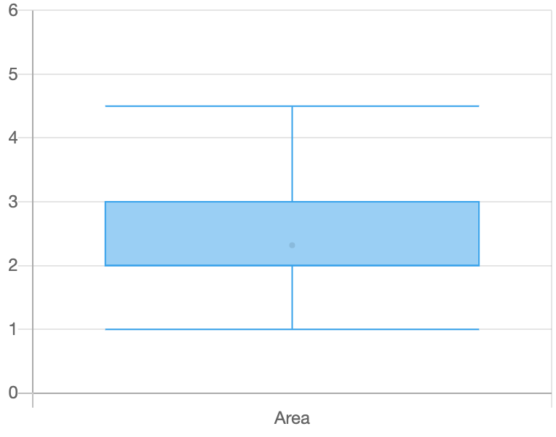

Figure 34: Boxplot visualization for restaurant area

It can be seen that most of the values belongs to first 4 areas instead of the fifth area.

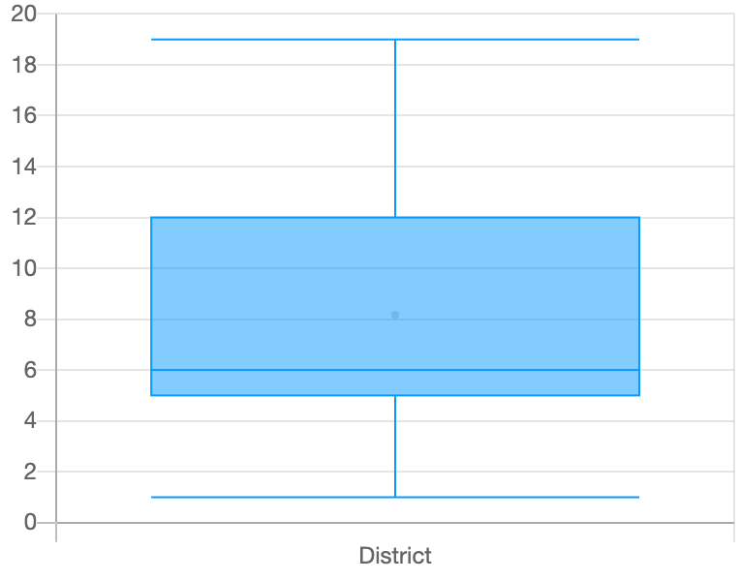

Figure 35: Boxplot visualization for Districts

It can be seen that 80% of the data lies in first 12 districts.

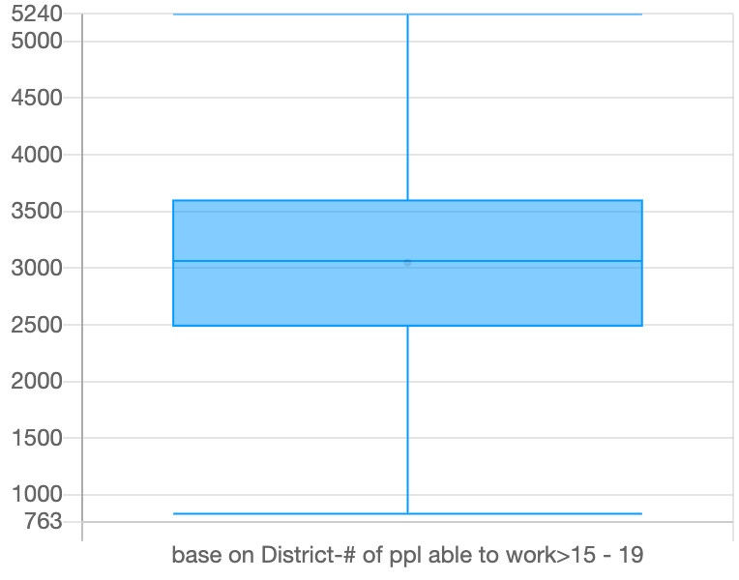

Figure 36: Boxplot of Number of people able to work from age 15 to 19 base on District

It can be seen that in districts there are mostly 2500 to 3500 people are available to work under 19.

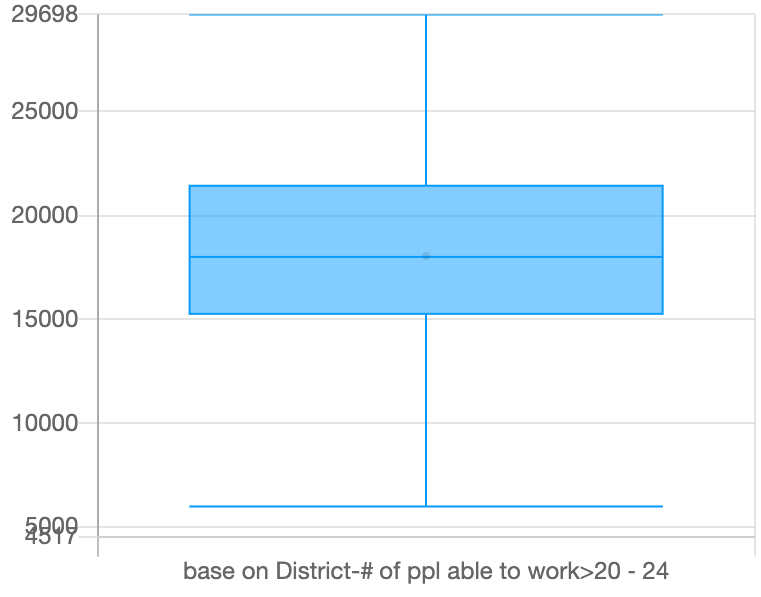

Figure 37: Boxplot of Number of people able to work from age 20 to 24 base on District

It can be seen that in districts there are mostly 15000 to 22000 people are available to work for age 20 to 24.

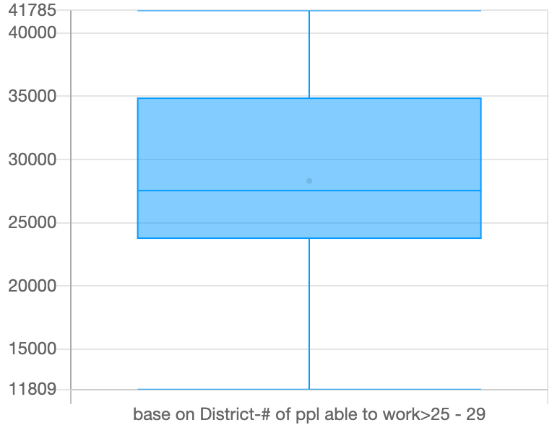

Figure 38: Boxplot of Number of people able to work from age 25 to 29 base on District

It can be seen that in districts there are mostly 24000 to 35000 people are available to work for age 25 to 29.

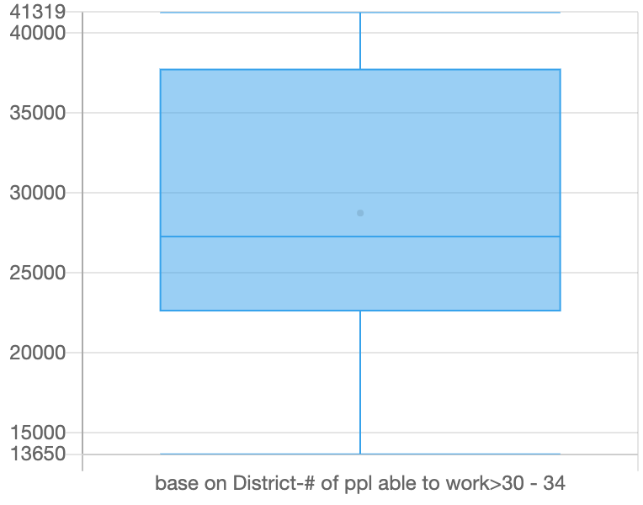

Figure 39: Boxplot of Number of people able to work from age 30 to 34 base on District

It can be seen that in districts there are mostly 23000 to 37000 people are available to work for age 30 to 34.

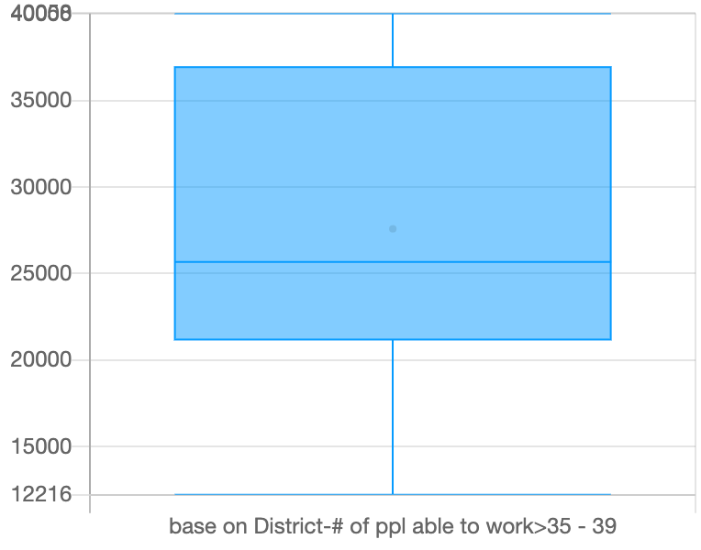

Figure 40: Boxplot of Number of people able to work from age 35 to 39 base on District

It can be seen that in districts there are mostly 22000 to 36000 people are available to work for age 35 to 39.

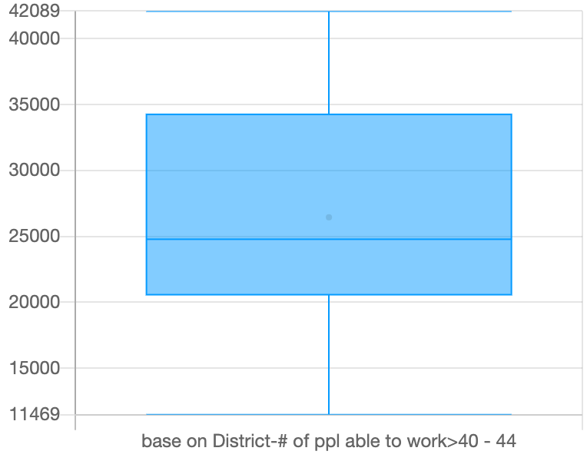

Figure 41: Boxplot of Number of people able to work from age 40 to 44 base on District

It can be seen that in districts there are mostly 20000 to 35000 people are available to work for age 40 to 44.

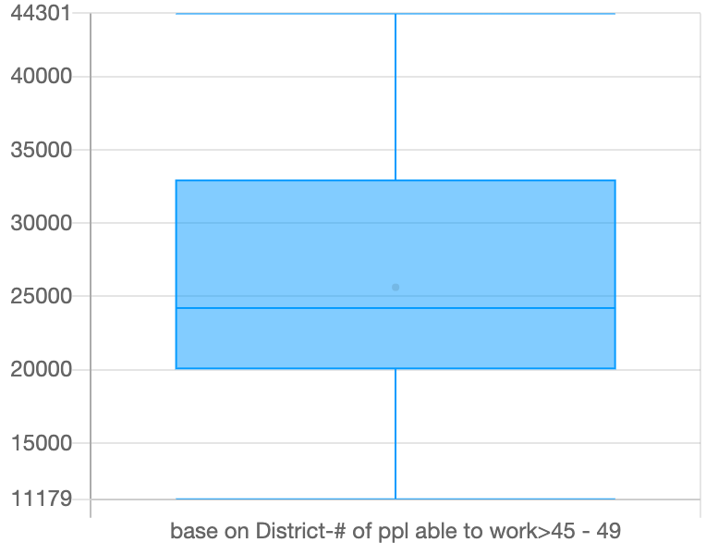

Figure 42: Boxplot of Number of people able to work from age 45 to 49 base on District

It can be seen that in districts there are mostly 20000 to 34000 people are available to work for age 45 to 49.

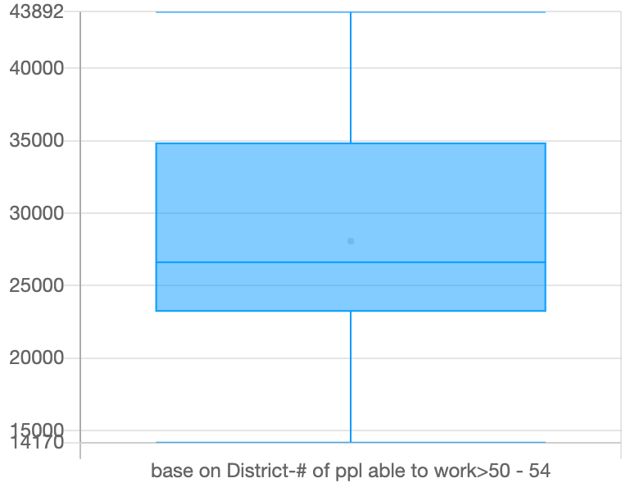

Figure 43: Boxplot of Number of people able to work from age 50 to 54 base on District

It can be seen that in districts there are mostly 24000 to 35000 people are available to work for age 50 to 54.

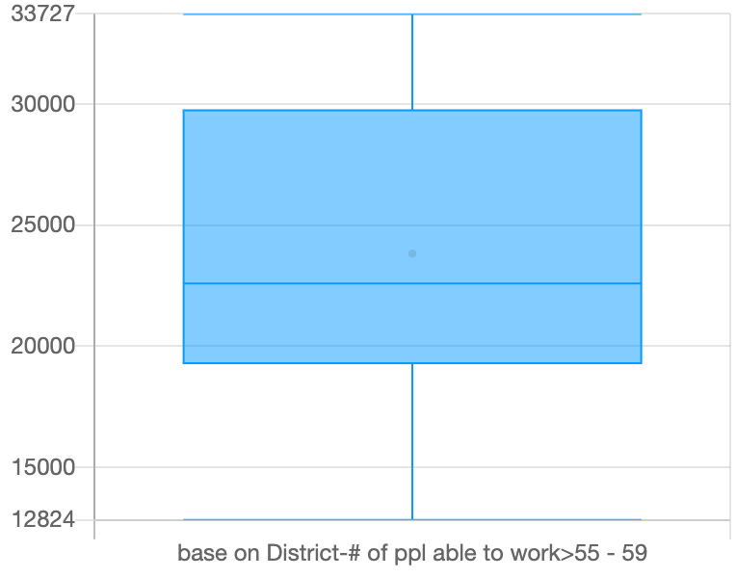

Figure 44: Boxplot of Number of people able to work from age 55 to 59 base on District

It can be seen that in districts there are mostly 18000 to 30000 people are available to work for age 55 to 59.

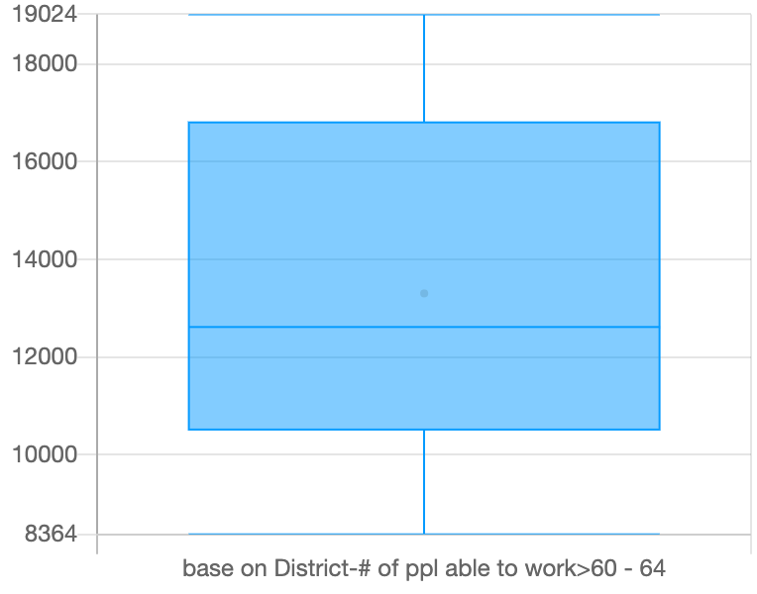

Figure 45: Boxplot of Number of people able to work from age 60 to 64 base on District

It can be seen that in districts there are mostly 12000 to 17000 people are available to work for age 60 to 64.

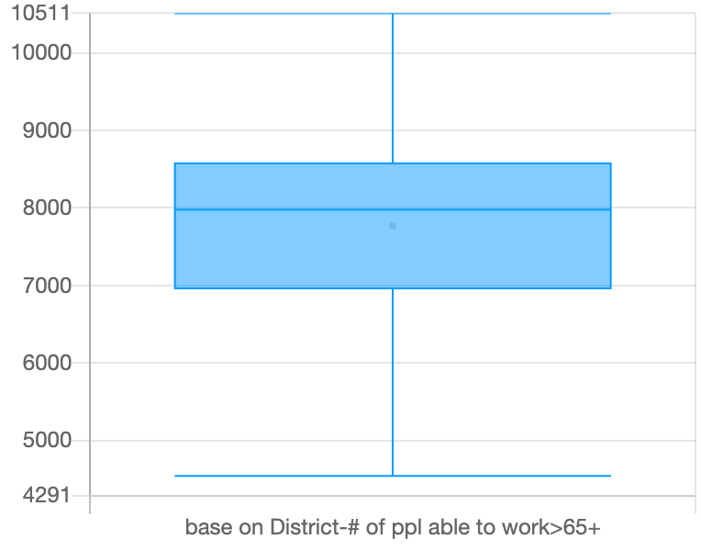

Figure 46: Boxplot of Number of people able to work from age 65 and above base on District

It can be seen that in districts there are mostly 7000 to 8500 people are available to work for age 65 and above.

Overall, It can also be concluded that mostly available for work are of age group are 20 to24.

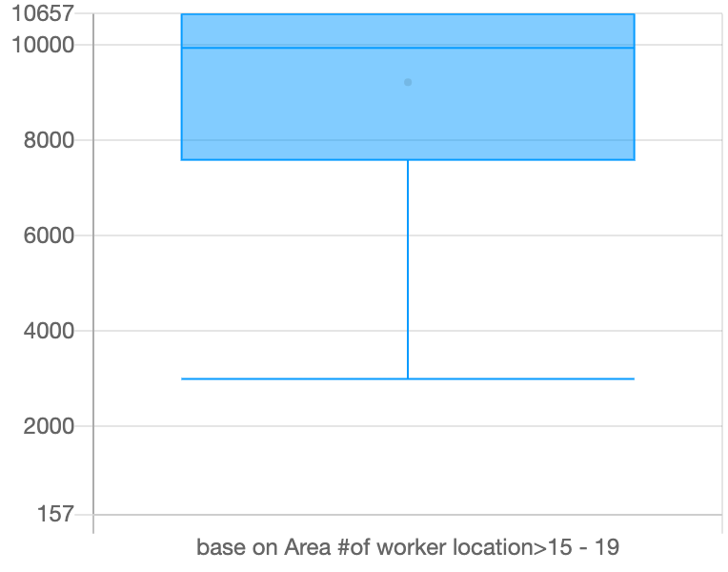

Figure 47: Boxplot of Number of people able to work from age 15 to 19 base on Area

It can be seen that mostly people below 19 are 7800 to 10500 in any restaurant base on Hong-Kong areas.

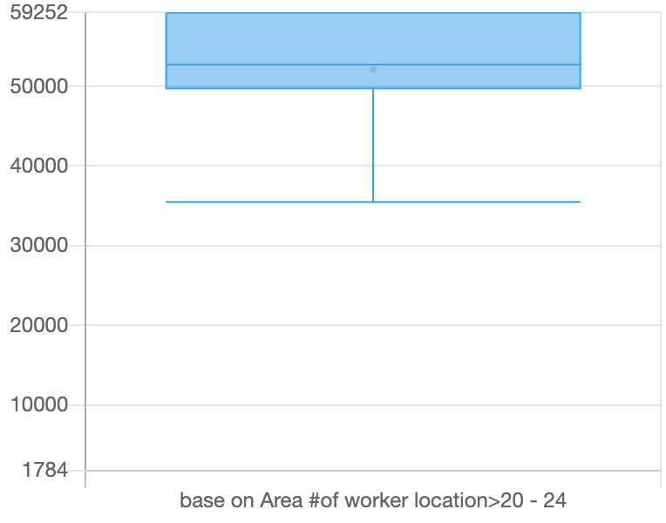

Figure 48: Boxplot of Number of people able to work from age 20 to 24 base on Area

It can be seen that mostly people from age 20 to 24 are 50000 to 60000 in any restaurant base on Hong-Kong areas.

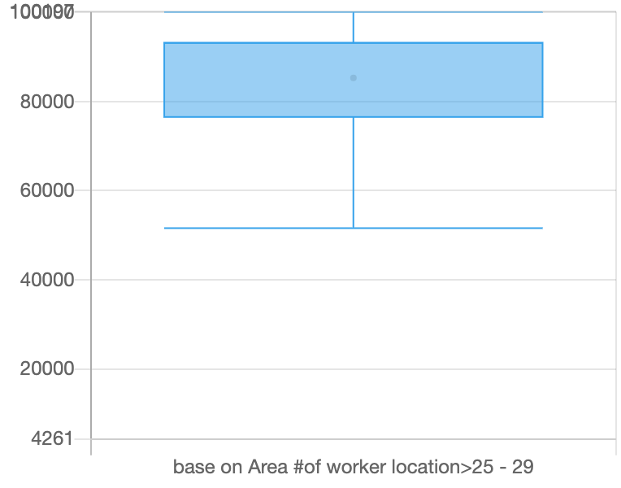

Figure 49:Boxplot of Number of people able to work from age 25 to 29 base on Area

It can be seen that mostly people from age 25 to 29 are 80000 to 95000 in any restaurant base on Hong-Kong areas.

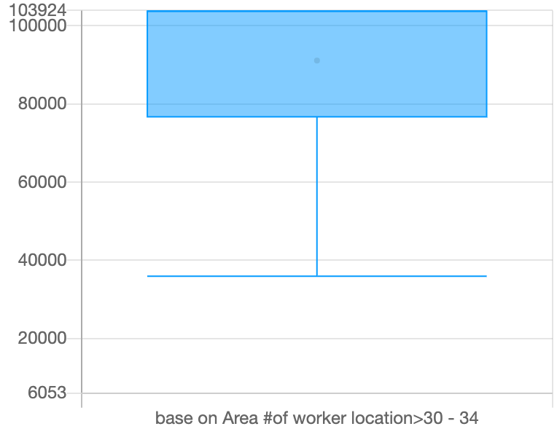

Figure 50: Boxplot of Number of people able to work from age 30 to 34 base on Area

It can be seen that mostly people from age 30 to 34 are 80000 to 100000 in any restaurant base on Hong-Kong areas.

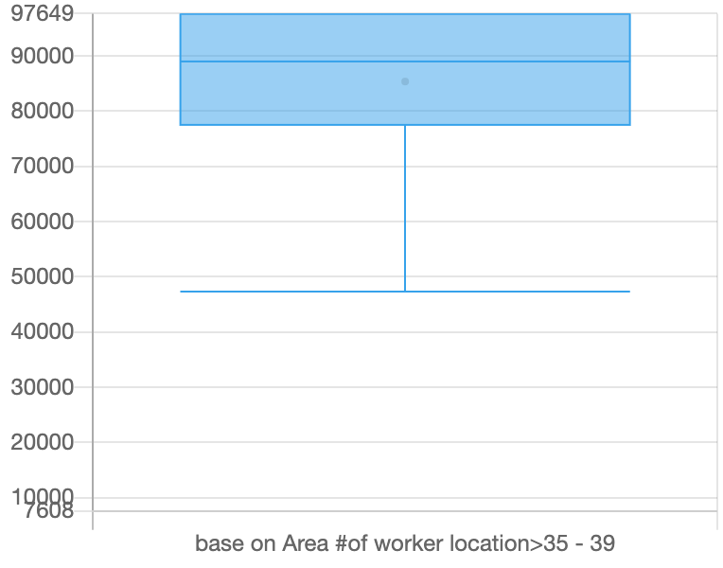

Figure 51: Boxplot of Number of people able to work from age 35 to 39 base on Area

It can be seen that mostly people from age 35 to 39 are 80000 to 98000 in any restaurant base on Hong-Kong areas.

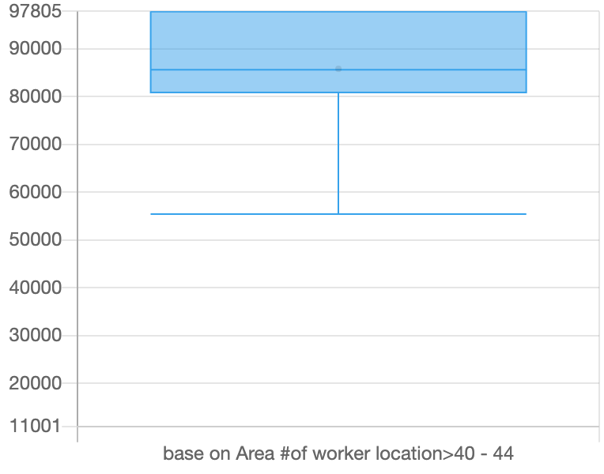

Figure 52: Boxplot of Number of people able to work from age 40 to 44 base on Area

It can be seen that mostly people from age 40 to 44 are 80000 to 98000 in any restaurant base on Hong-Kong areas.

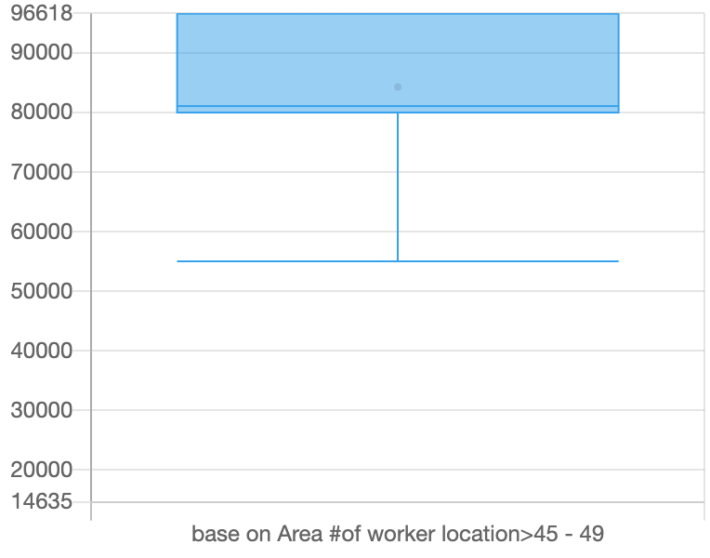

Figure 53: Boxplot of Number of people able to work from age 45 to 49 base on Area

It can be seen that mostly people from age 45 to 49 are 80000 to 98000 in any restaurant base on Hong-Kong areas.

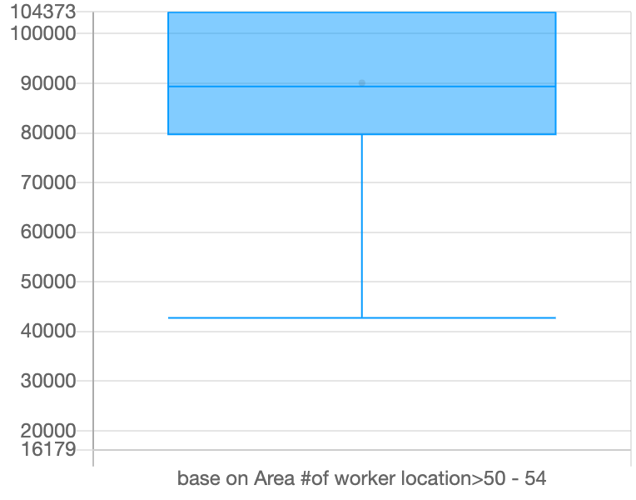

Figure 54: Boxplot of Number of people able to work from age 50 to 54 base on Area

It can be seen that mostly people from age 50 to 54 are 80000 to 101200 in any restaurant base on Hong-Kong areas.

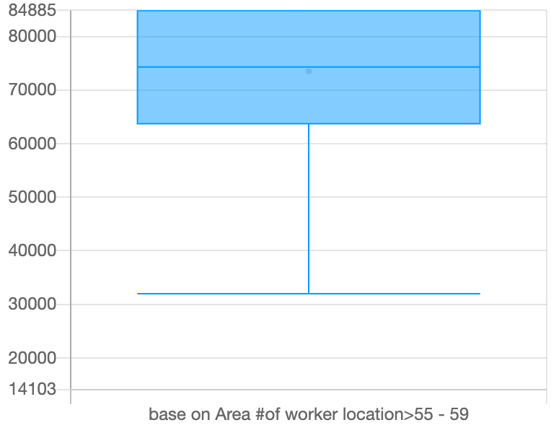

Figure 55: Boxplot of Number of people able to work from age 55 to 59 base on Area

It can be seen that mostly people from age 55 to 59 are 65000 to 85000 in any restaurant base on Hong-Kong areas.

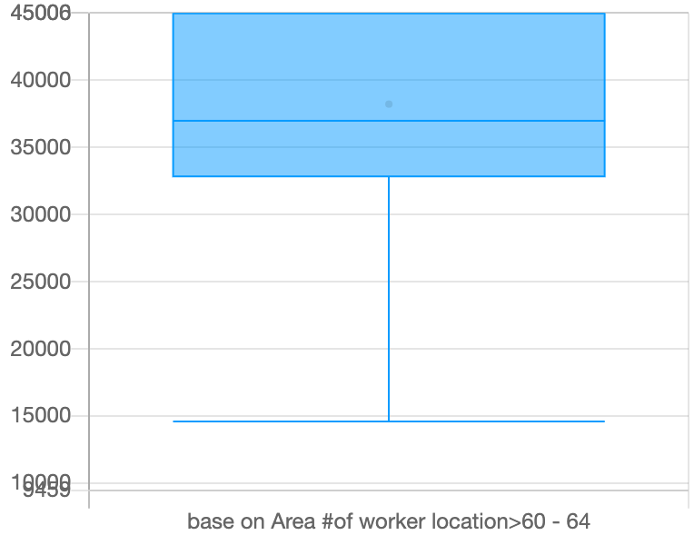

Figure 56: Boxplot of Number of people able to work from age 60 to 64 base on Area

It can be seen that mostly people from age 60 to 64 are 33000 to 45000 in any restaurant base on Hong-Kong areas.

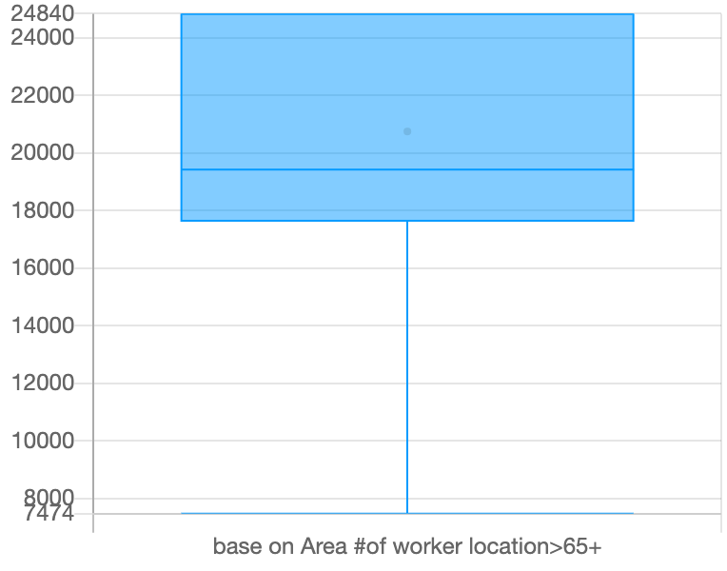

Figure 57: Boxplot of Number of people able to work from age 65 and above base on Area

It can be seen that mostly people from age 65 and above are 17500 to 25000 in any restaurant base on Hong-Kong areas.

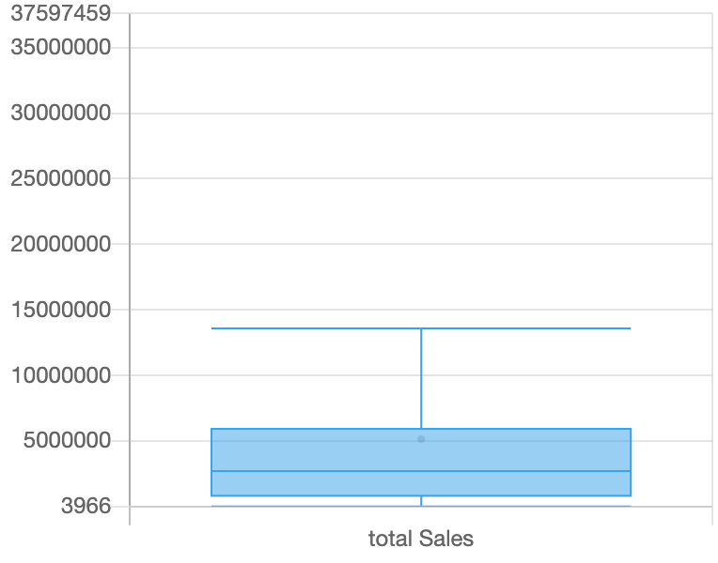

Figure 58: Boxplot of total sales

It can be seen that the total sales are mostly below 10,000,000

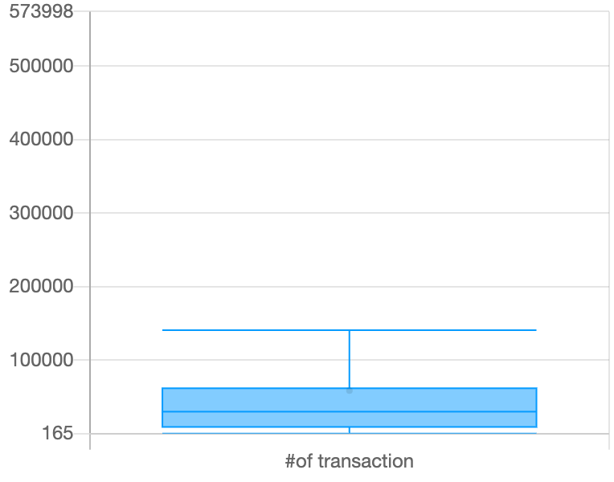

Figure 59: Boxplot of Number of transactions

It can be seen that the number of transactions are mostly below 150000.

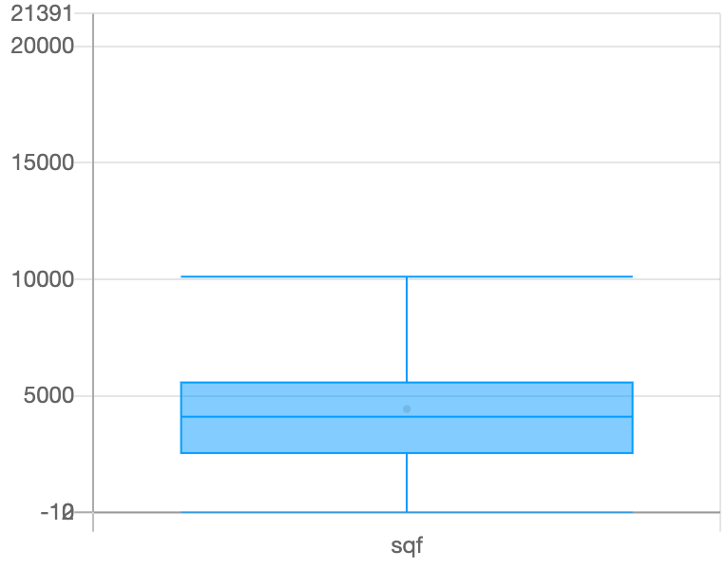

Figure 60: Boxplot of sqf

It can be seen that mostly values of sqf are below 10,000.

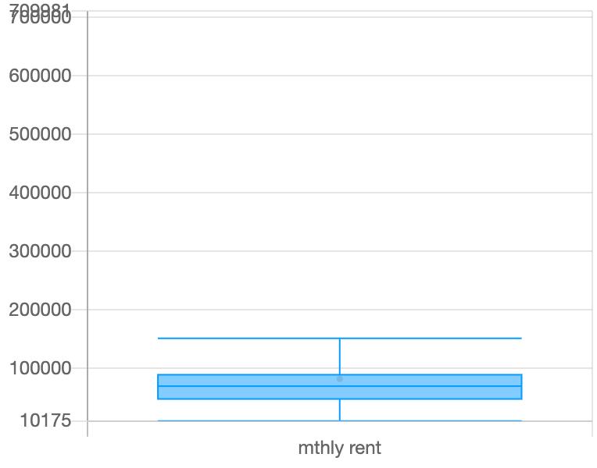

Figure 61: Boxplot of monthly rent

It can be seen that mostly values of monthly rent are below 180,000.

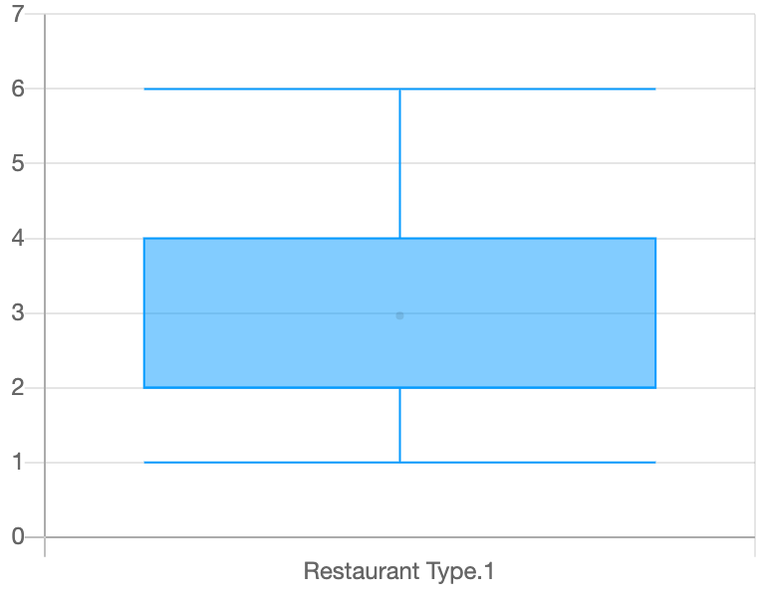

Figure 62: Boxplot of restaurant types

It can be seen that mostly monthly values belong to first 4 types.

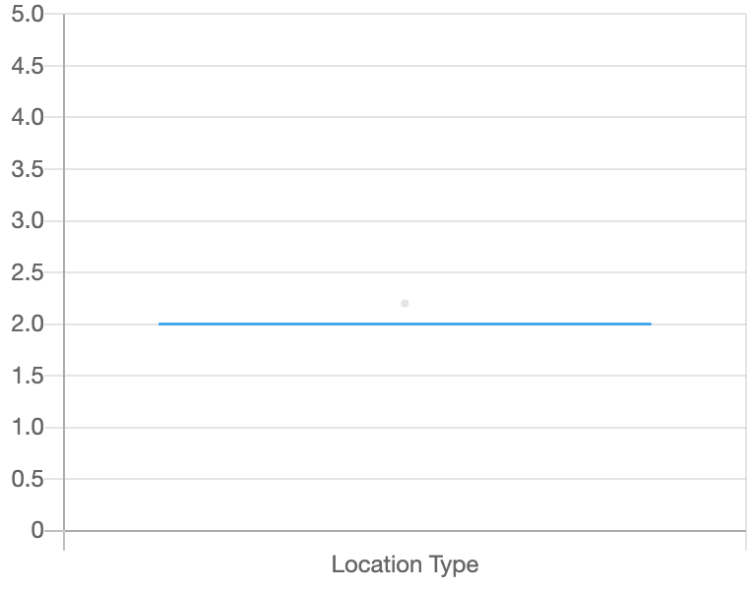

Figure 63: Boxplot of location types

It can be seen that mostly the 2nd location has more users.

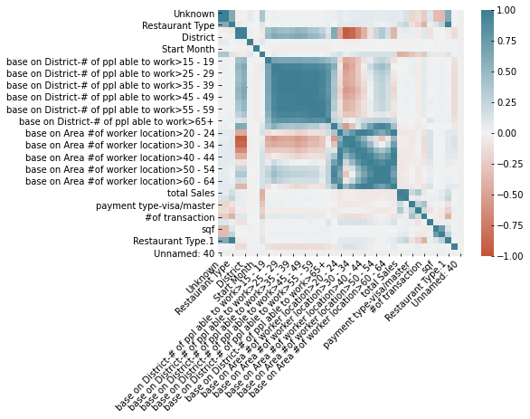

Figure 64: Co relation plot for all features

The above figure us showing that total sales only have good co relation with number of transitions.

Classification Algorithms Results for Restaurant Status Prediction

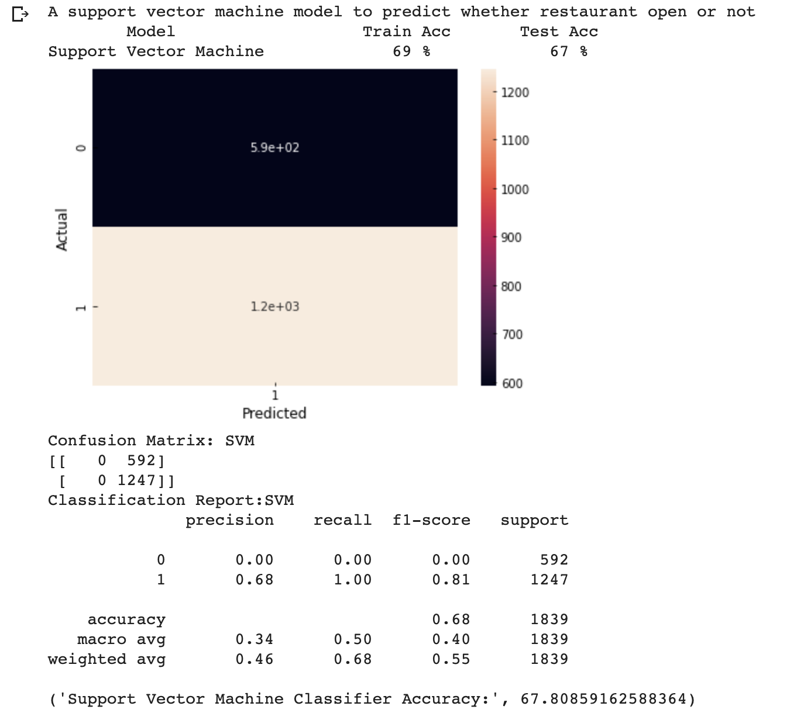

Figure 65: Results of Support Vector Machine Classifier for Restaurant Status Predictions

Figure 65 is showing the output of SVM model testing. It can be seen that model has wrongly predicted 565 not open status as open. Also, the accuracy becomes 68%. But this is showing that SVM isn’t the good algorithm for this purpose.

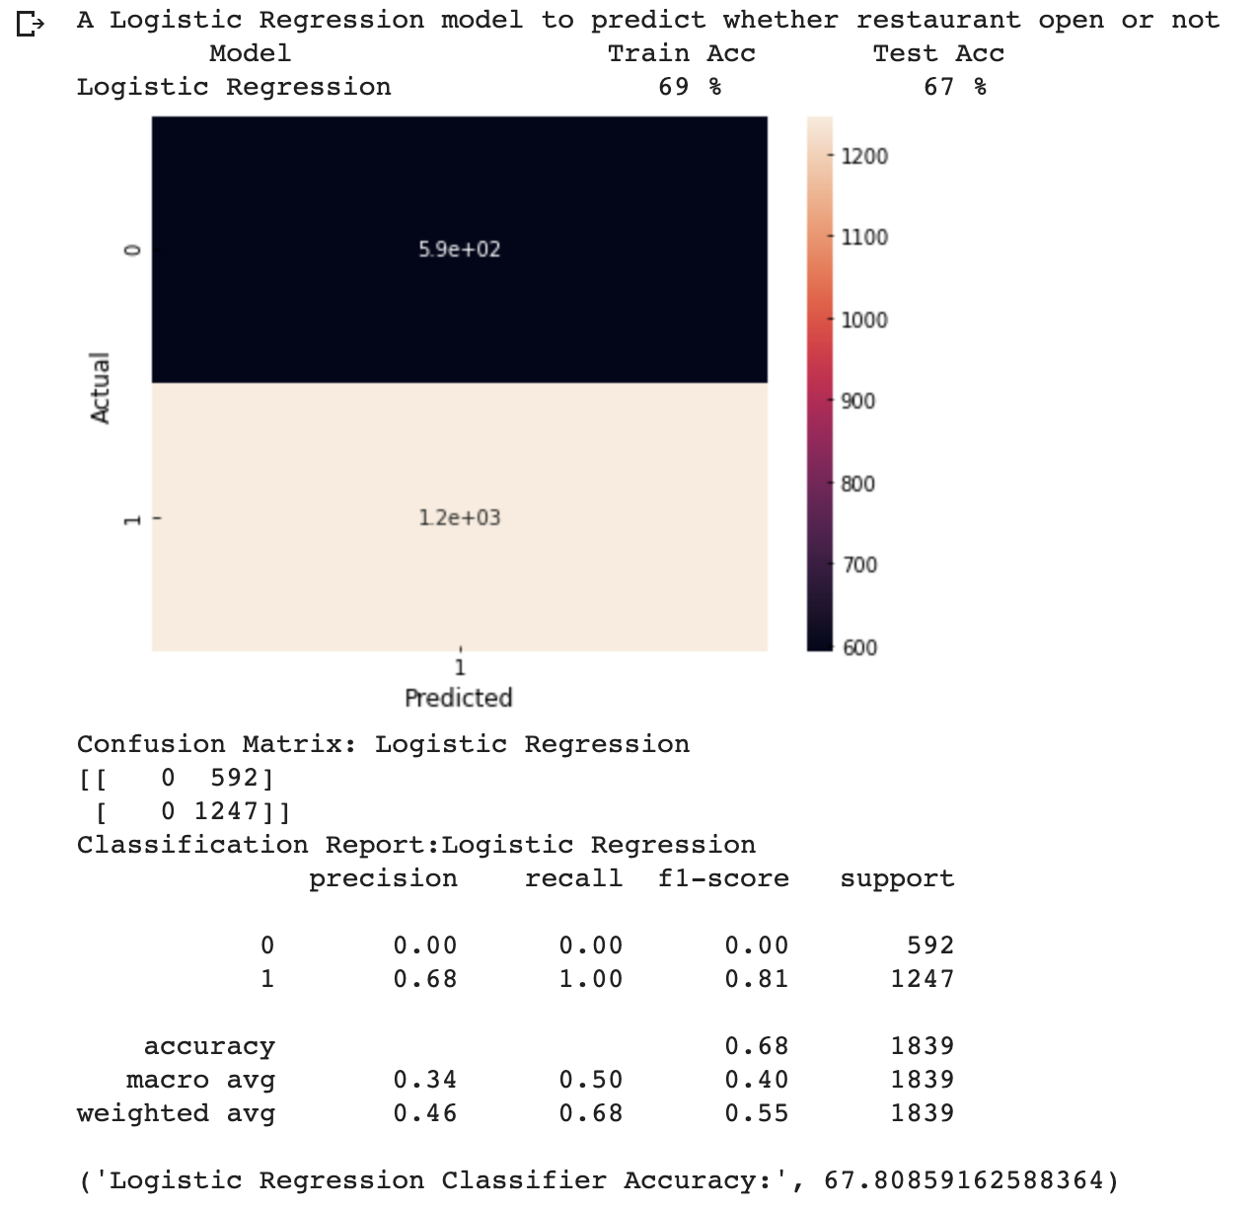

Figure 66: Results of Logistics Regression for Restaurant Status Predictions

Figure 66 is showing the output of Logistic model testing. It can be seen that model has wrongly predicted 542 not open status as open. Also, the accuracy becomes 69%. But this is showing that Logistic Regression isn’t the good algorithm for this purpose.

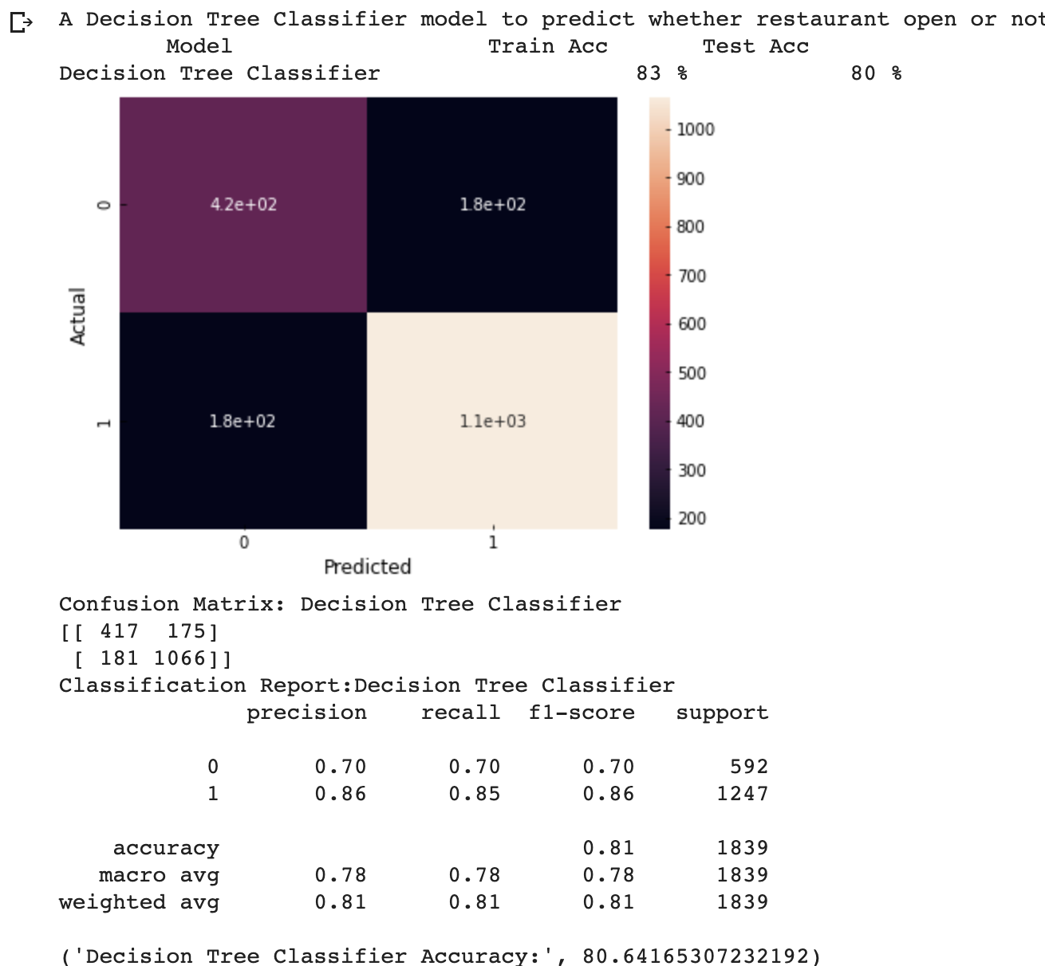

Figure 67: Result of decision tree Classifier for restaurant status prediction

Figure 67 is showing the output of Decision Tree Classifier testing. It can be seen that model has wrongly predicted 91 not open status as open. Also, the accuracy becomes 80%. But this is showing that Decision Tree classifier is a good algorithm for this purpose.

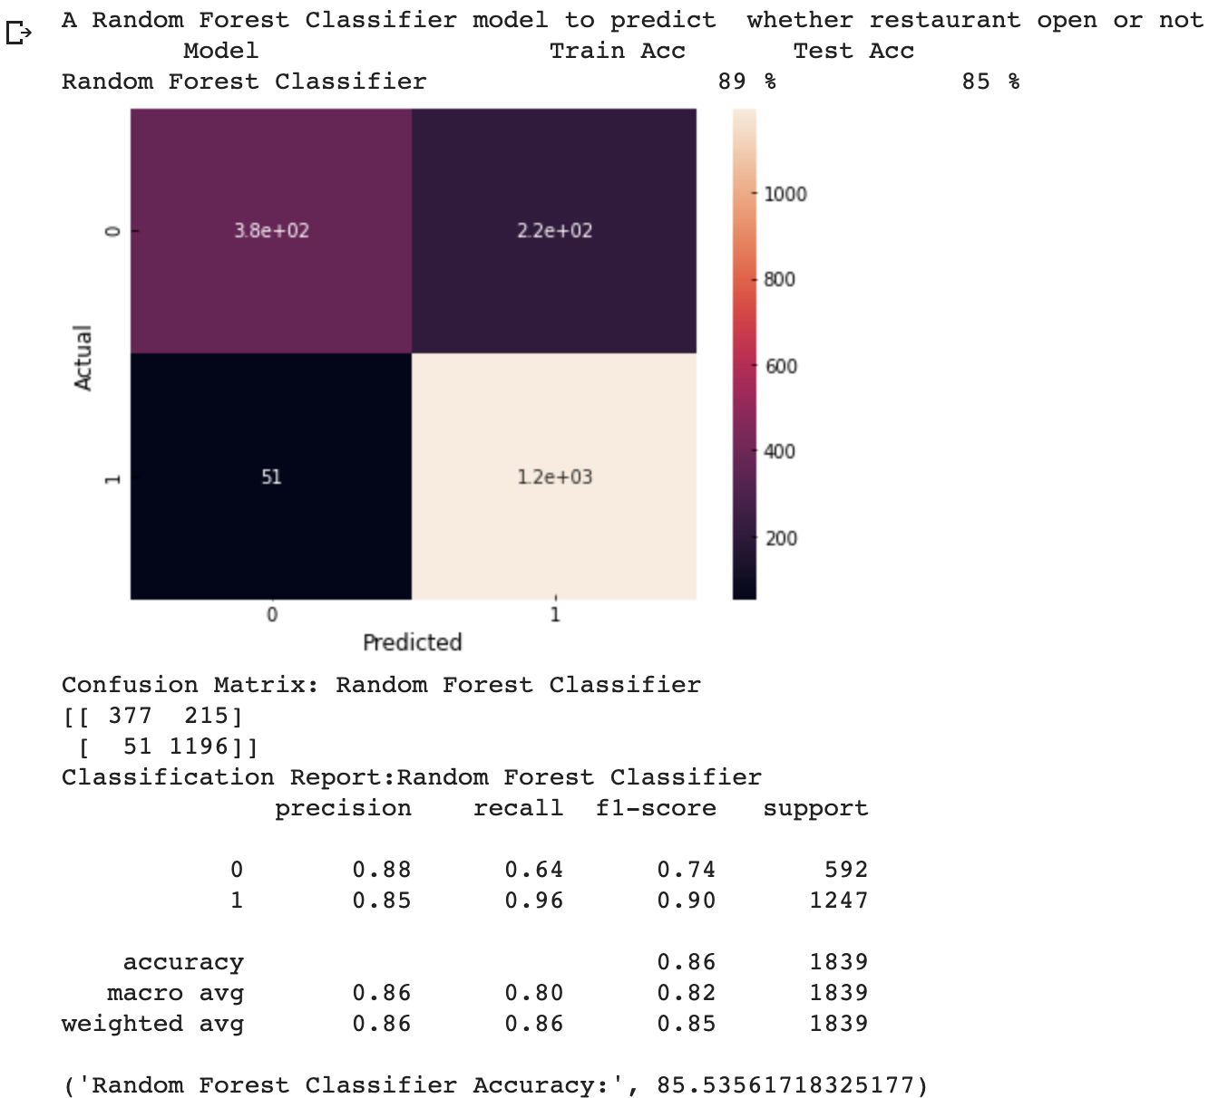

Figure 68: Results of random forest for restaurant status prediction

Figure 68 is showing the output of Random Forest Classifier testing. It can be seen that model has wrongly predicted 42 not open status as open. Also, the accuracy becomes 85%. But this is showing that Random Forest classifier is a good algorithm for this purpose.

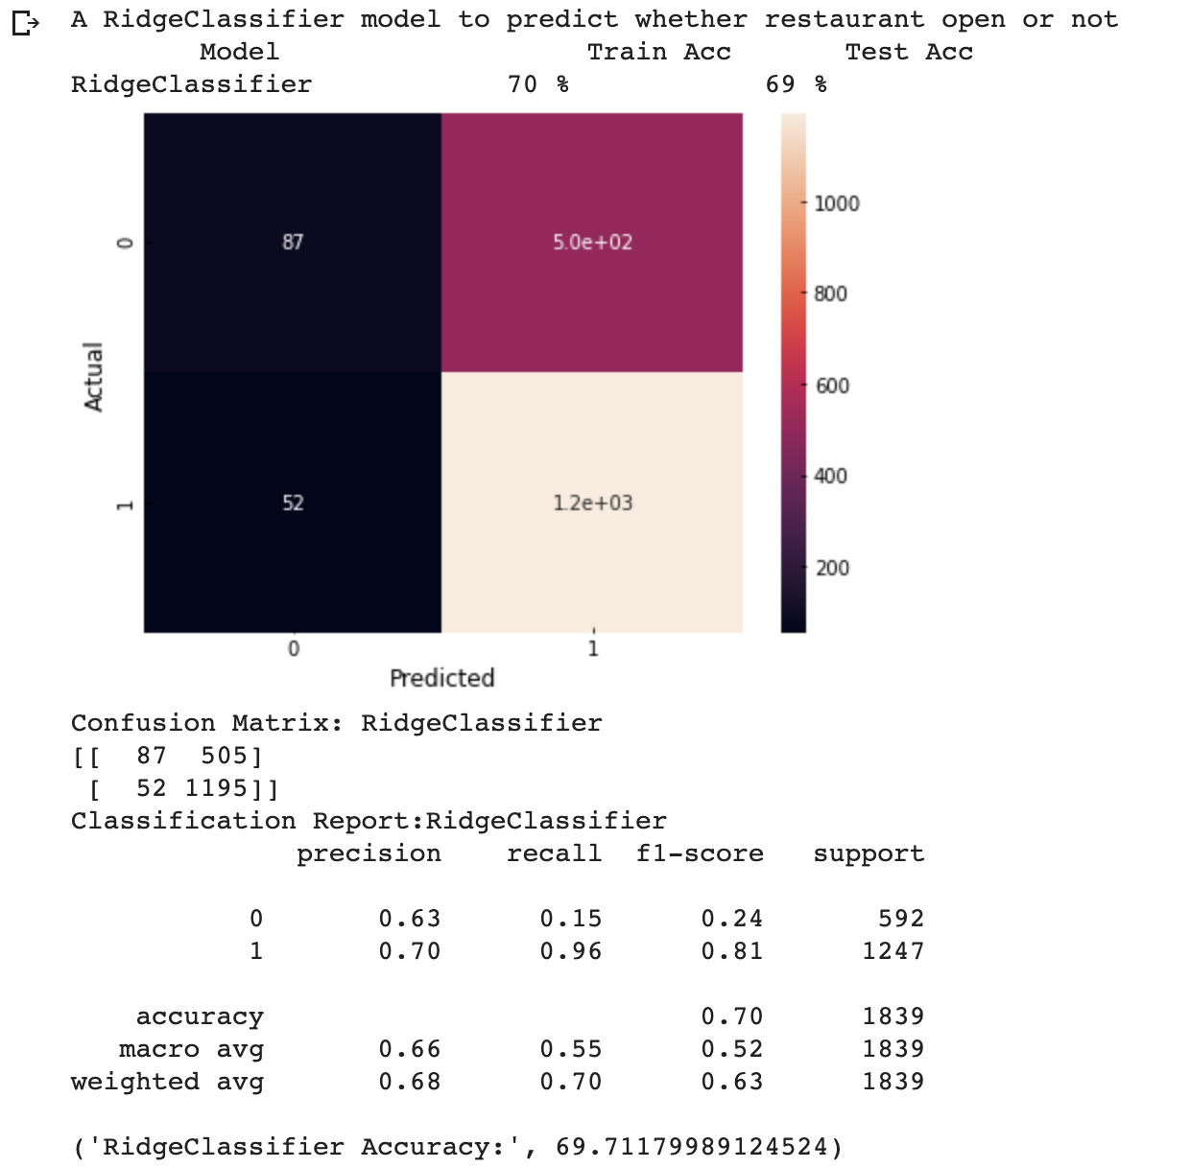

Figure 69: Results of ridge classifier for restaurant status Prediction

Figure 69 is showing the output of Ridge Classifier testing. It can be seen that model has wrongly predicted 351 not open status as open. Also, the accuracy becomes 69%. But this is showing Ridge Classifier is an average algorithm for this purpose.

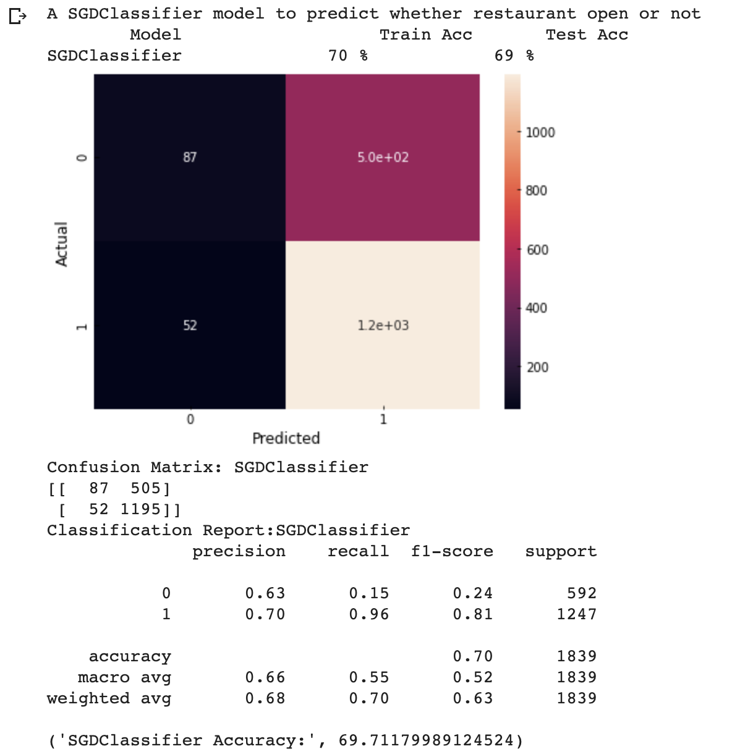

Figure 70: Results of SGD Classifier for restaurant status prediction

The above figure is showing the output of SDG Classifier testing. It can be seen that model has wrongly predicted 351 not open status as open. Also, the accuracy becomes 69%. But this is showing SDG Classifier is an average algorithm for this purpose.

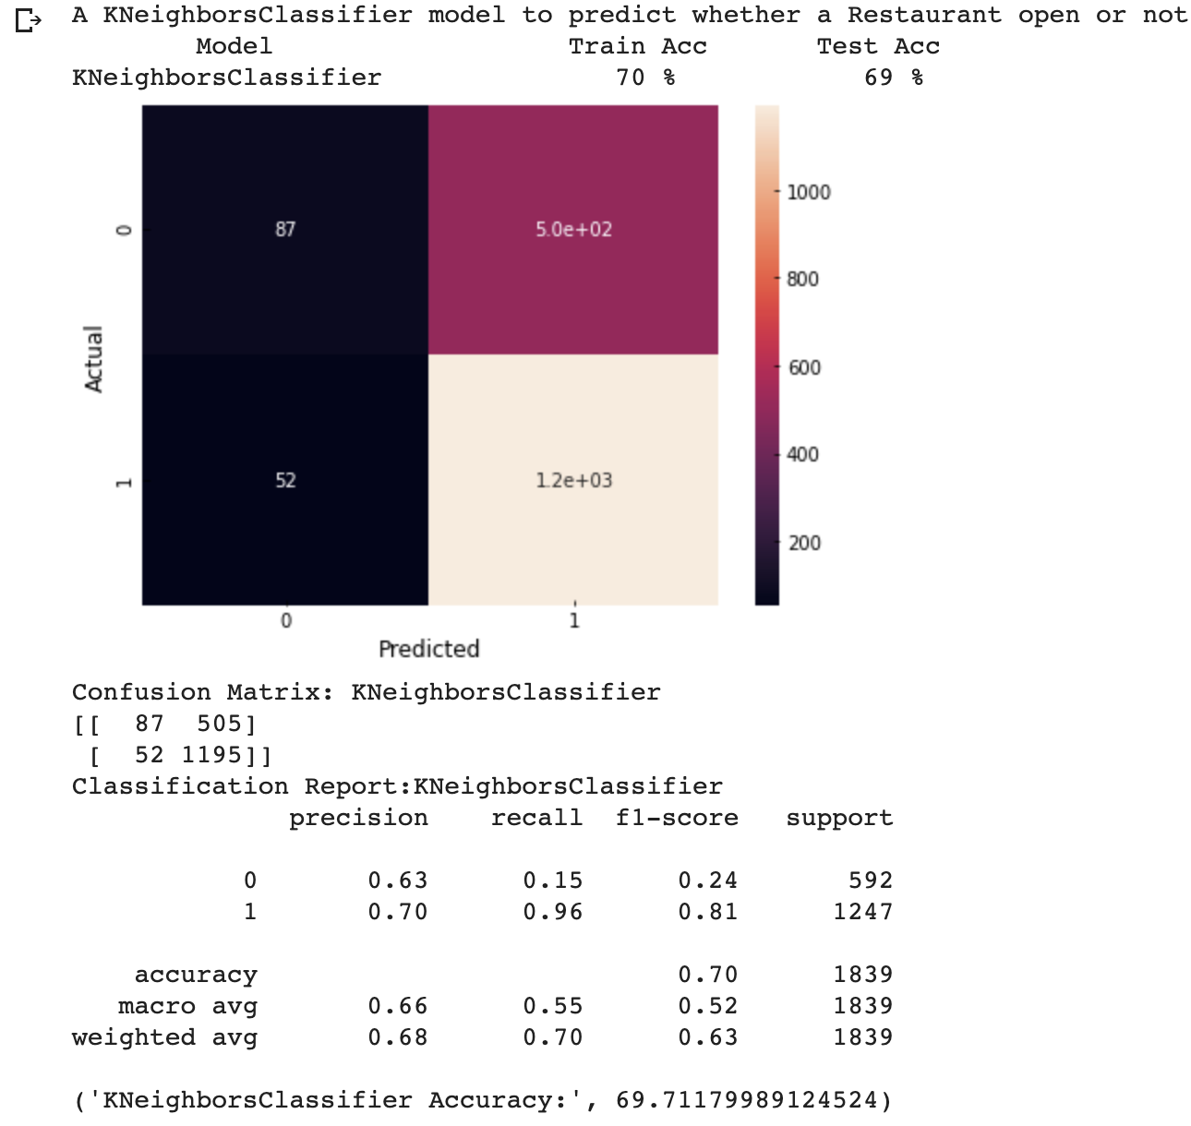

Figure 71: Results of K Neighbor classifier for restaurant status predictions

The above figure is showing the output of KNN Classifier testing. It can be seen that model has wrongly predicted 351 not open status as open. Also, the accuracy becomes 69%. But this is showing KNN Classifier is an average algorithm for this purpose.

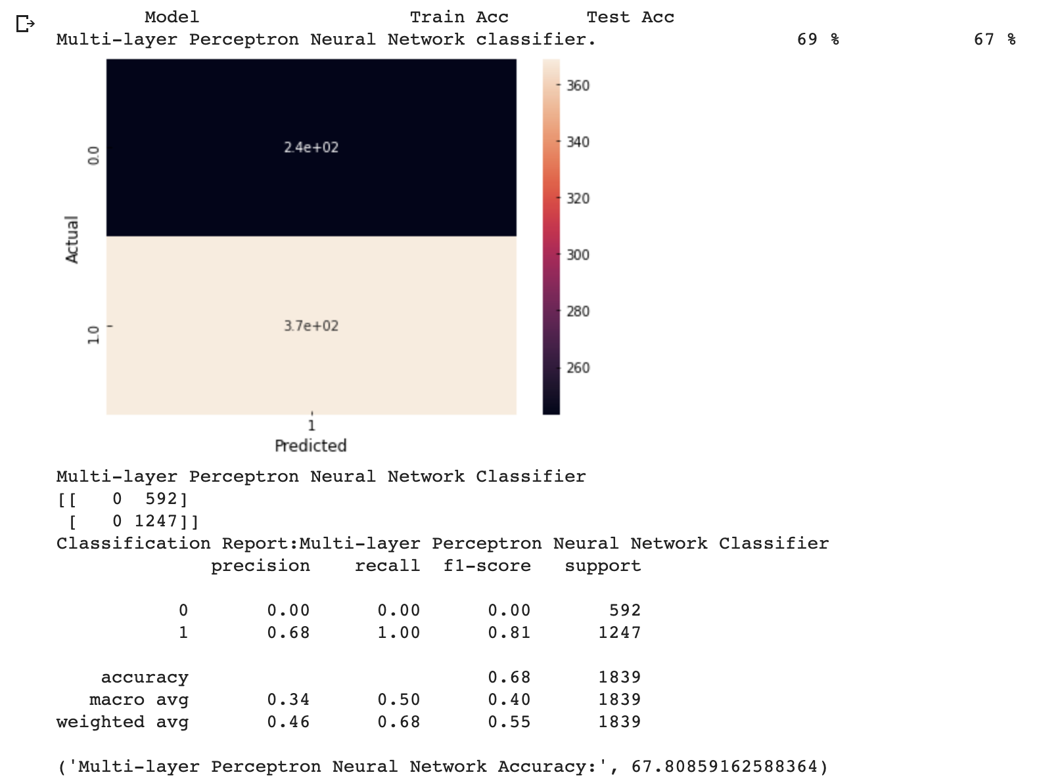

Figure 72: Results MLP classifier for restaurant status predictions

The above figure is showing the output of MLP Classifier testing. It can be seen that model has wrongly predicted 565 not open status as open. Also, the accuracy becomes 67%. This is showing MLP Classifier is a bad algorithm for this purpose.

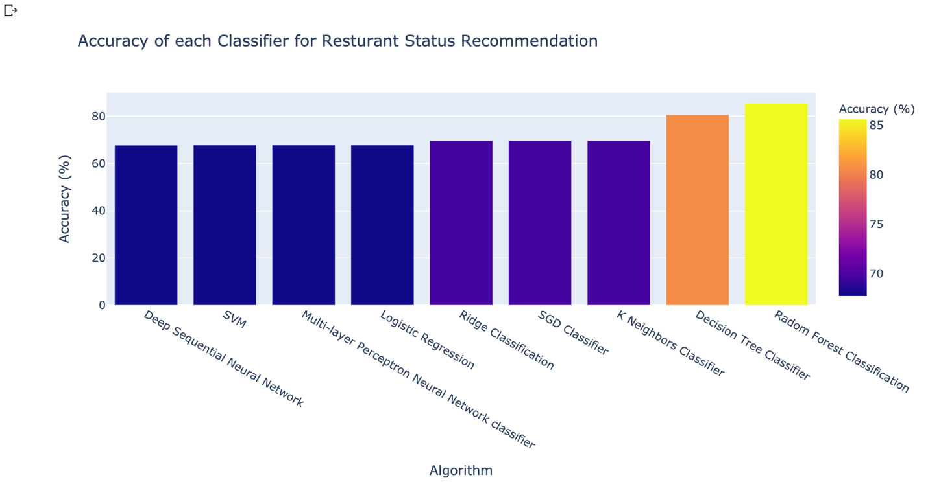

Figure 73: Restaurants Recommendations accuracy comparisons

The above Figure is showing that random forest classification has achieved the best accuracy for restaurant status Predictions.

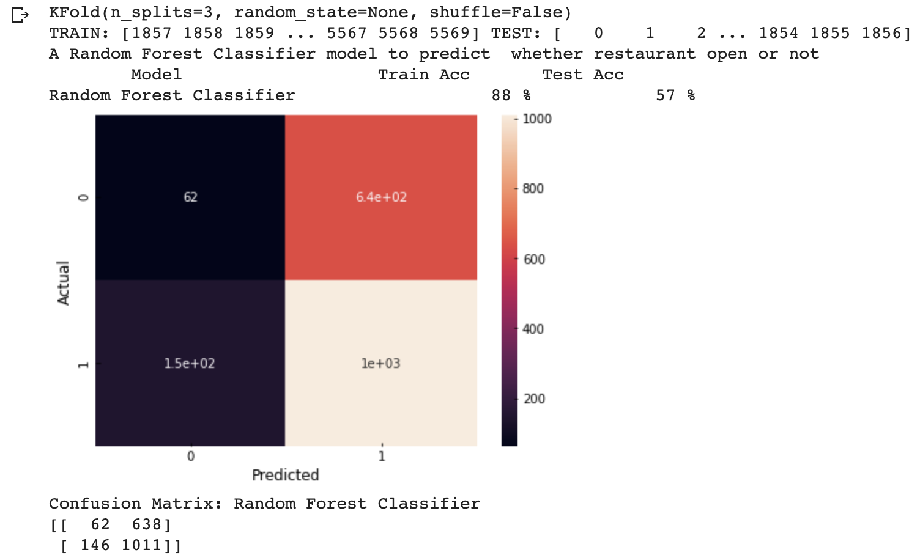

Figure 74: K fold validation step-1 results

K- Fold Validation was applied on Random Forest Classification. But it can be seen the random forest isn’t a sensible for the case where we are predicting based on increasing value.

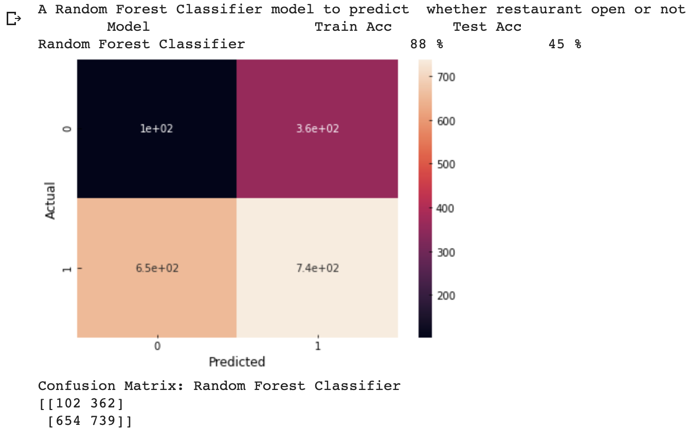

Figure 75: K Fold validation step 2 results

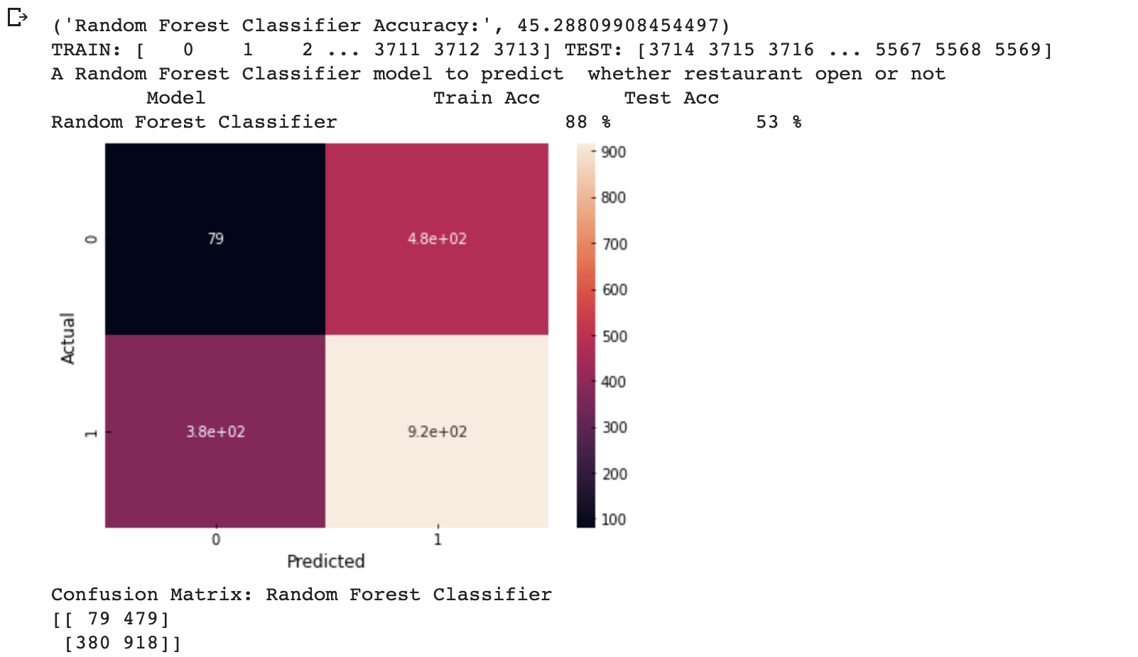

Figure 76: K Fold Validating step 3 results

Figure 75 and 76 are also showing that K Fold Cross Validation technique has proven the random forest is also so much not suitable for the purpose, but it is also showing that selecting the training and testing randomly is very important.

Regression Algorithms Results for Total Sales Prediction

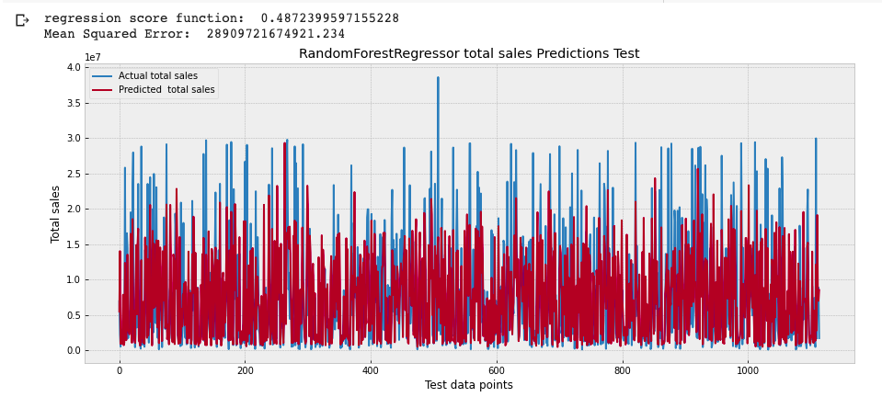

Figure 77: Random Forest Regression total sales predictions original and Predicted results for test data points

The above figure is showing that random forest has mostly high mean square root but it has good regression score function.

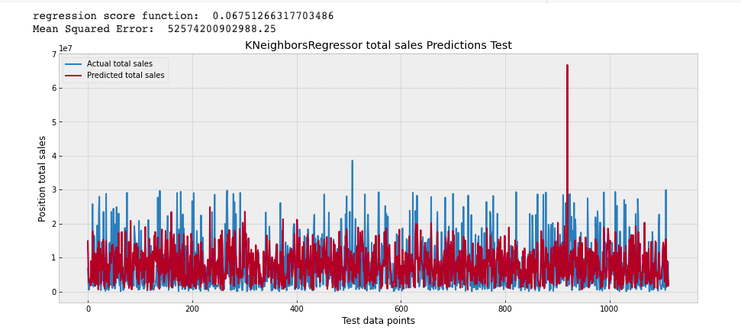

Figure 78: K Neighbor Regression total sales predictions original and Predicted results for test data points

The above figure is showing that K Neighbor regression is also mostly high mean square root but it has good regression score function.

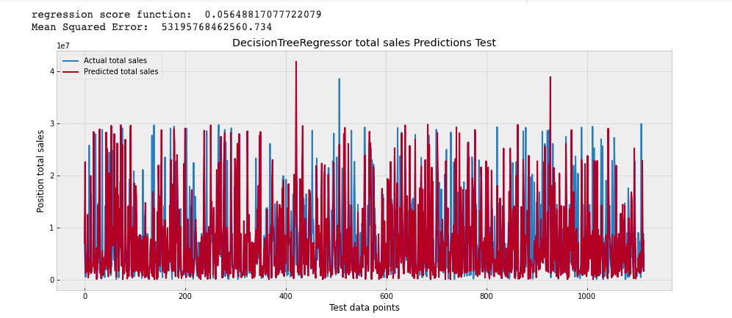

Figure 79: Decision Tree Regression for total sales predictions original and Predicted results for test data points

The above figure is showing that Decision Tree regression is also mostly high mean square root but it has good regression score function.

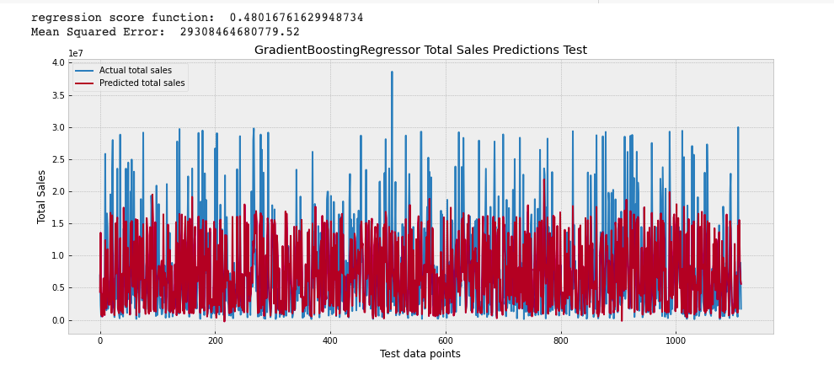

Figure 80: Gradient Boosting Regression for total sales predictions original and Predicted results for test data points

The above figure is showing that Decision Tree regression is also mostly high mean square root and also it does not have a good regression score function.

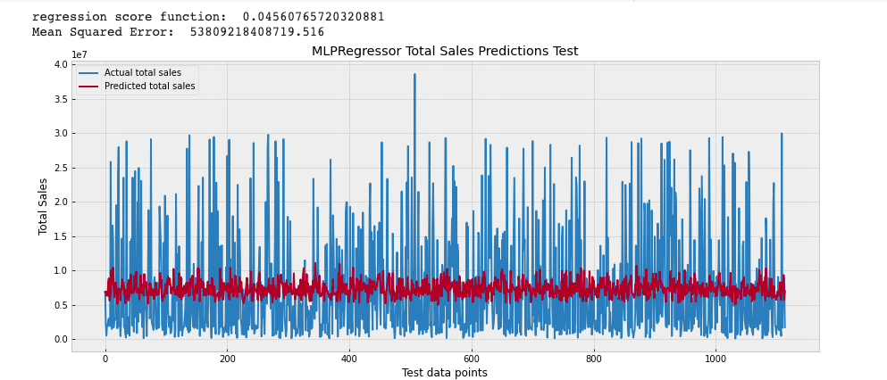

Figure 81: MLP Regression for total sales predictions original and Predicted results for test data points

The above figure is showing that MLP is also mostly high mean square root and also it does not have a good regression score function.

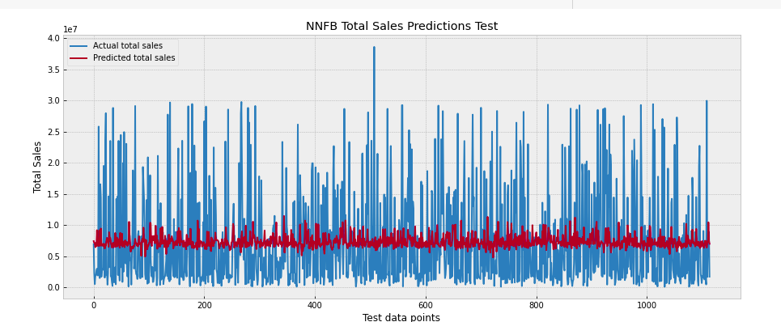

Figure 82: Neural Network Regression for total sales predictions original and Predicted results for test data points

The above figure is showing that Neural Network is also mostly high mean square root and also it does not have a good regression score function.

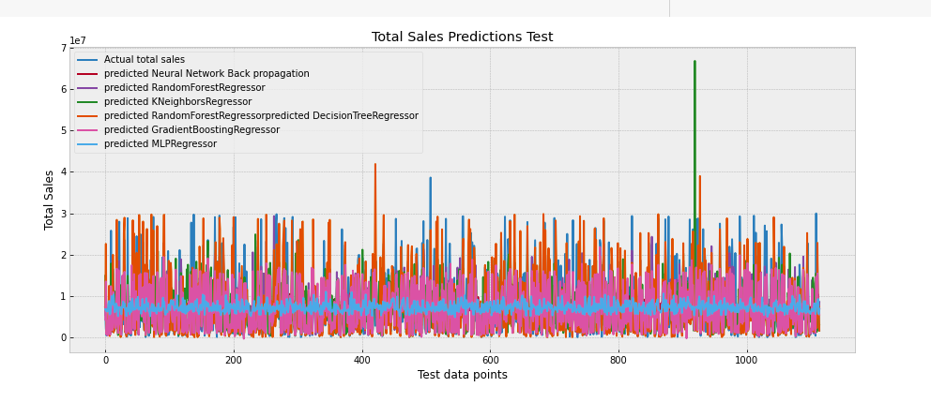

Figure 83: Combined plot for regression results

The combined plot is showing that there are differences in prediction of each algorithm.

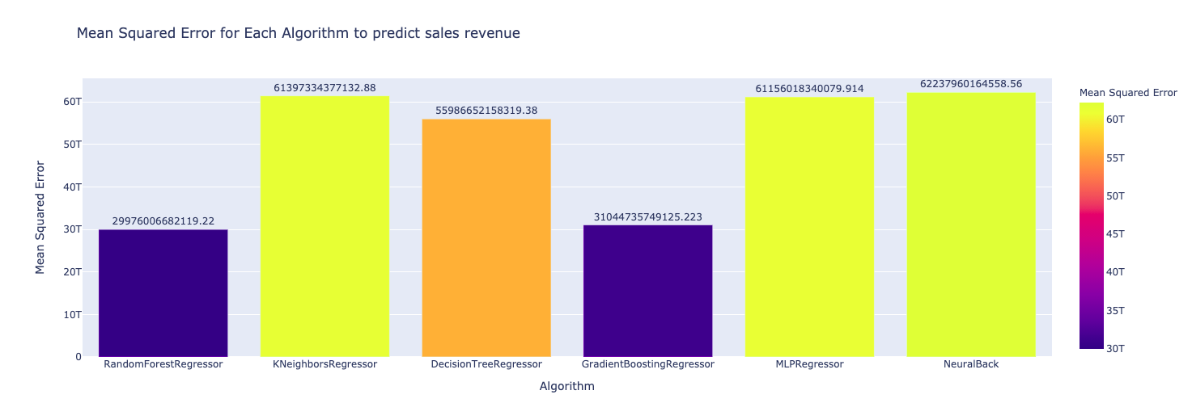

Figure 84: Mean Squared Algorithm for each algorithm to predict sales

The above figure is showing that K Neighbor Regression has the minimum mean squared error.

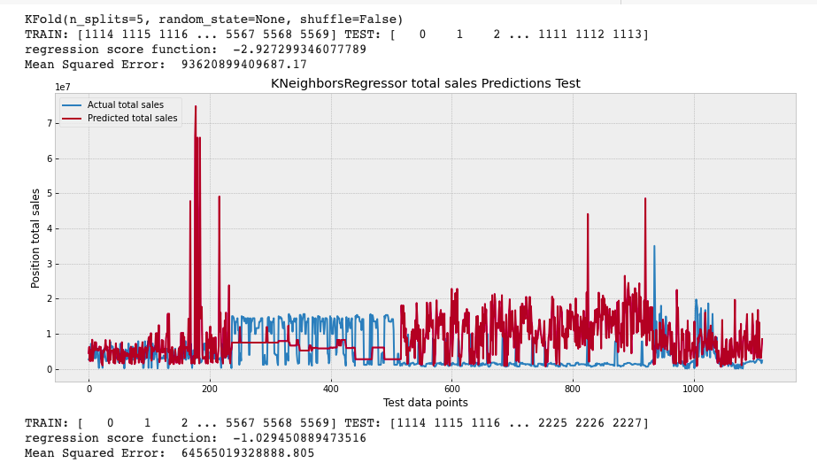

Figure 85: K Fold Validation Split 1 results

Cross Validation using K Neighbor Regression was done.

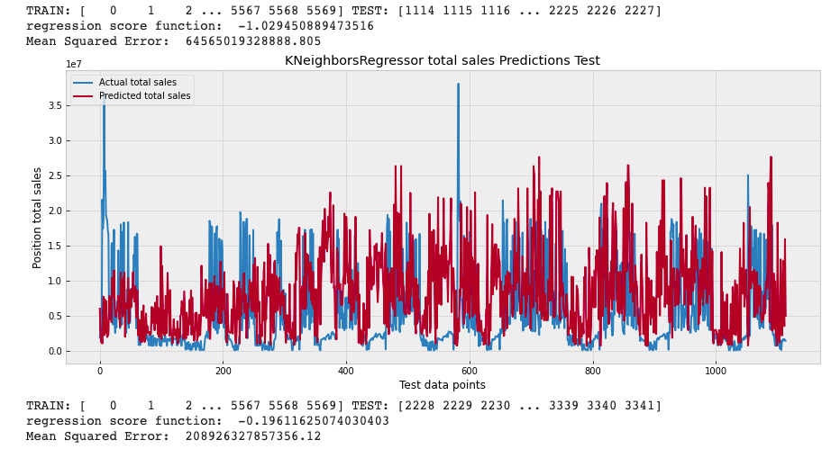

Figure 86: K Fold Validation Split 2 results

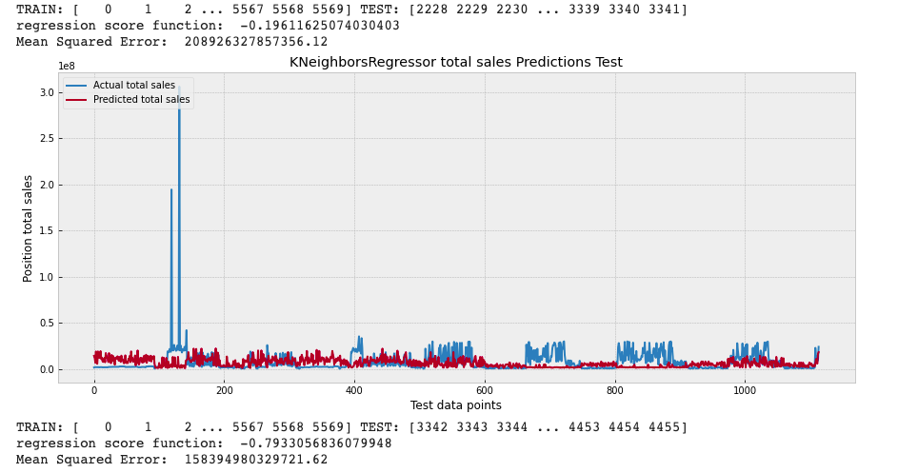

Figure 87: K Fold Validation split 3 results

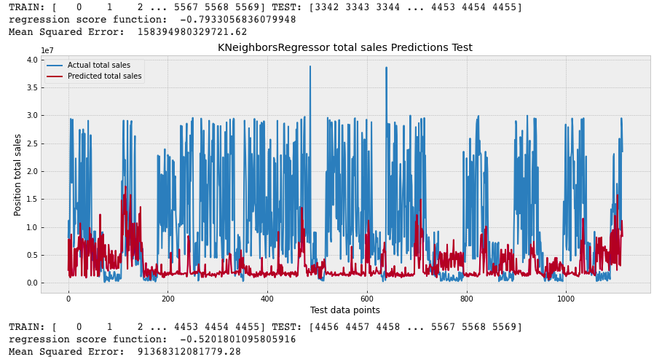

Figure 88: K Fold Validation split 4 results

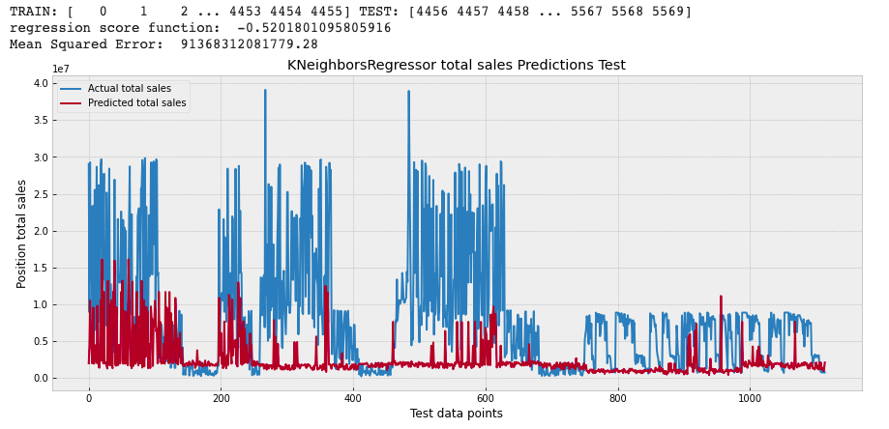

Figure 89: K Fold Validation split 5 results

Figure 85 to 89 are showing that it is difficult to predict the increasing and decreasing the price when we have 1125 continuous values are predicted. It can be seen that continues selection is not reasonable and hence the random selection should be done for the model to perform best.

## **Result discussions**

From above results it can be seen that mostly people of age 20 to 24 are the key age to focus for more sales revenue in any of District. In any area the age group 25 to 44 is very much active spending in restaurant, but it can be said that the continues data is difficult to predict and to tune the model random section of rows must be done.

## **Chapter summary**

Given its popularity, rate of adoption, and flexibility, Python is well performing in my research case and I would recommend or preferred language for ML development. There are also many available Python packages to perform numerous tasks, including data cleaning, visualization, and model development. Some of these key packages are included in this chapter such as Scikit-learn and Keras. The 7 steps of model development mentioned in this chapter can be leveraged while developing any ML based model in my case.

# **CHAPTER 5:**

# **CONCLUSIONS**

## **Key Findings of Research**

From this research it was checked that the data selection to fit in algorithms must be selected randomly for more accuracy. It was checked that Random Forest Classification is the best algorithm for the Restaurant Status Prediction. It was checked that K Neighbor Regression is one of the best algorithms for total sales predictions. It was also checked that mostly people available for working in Hong Kong are from age 20 to 40.

## **The Limitations**

When K Fold Cross Validation was applied on the best algorithms for both cases the accuracy was dropped hence the random selection of data should be done to get the accurate results.

The dataset was relatively small then the total number of Restaurants in the Hong Kong hence in future more data is needed.

## **Recommendations and Further Studies**

In future more, data can be added to fit into the algorithms so that they can be more accurate. In future parameter tuning can also be done to get maximum accuracy for each algorithm.

## **Social, Ethical and Legal Issues**

Big data analysis with ML, especially data about the specific business operation data, raises very important ethical issues and we shouldn’t be ignored. The client wanted to create technological advances while keeping a close eye on the restaurant's performance and sales projections. Despite the fact that this research using specific restaurant data with no personal privacy concerns, I still need to delete the restaurant names when employing data mining and ML techniques in the analysis of human rights and equality. These data are utilized directly to decide on many of the commercial applications described in the research: Should credit be given to me? If so, which credit line should we have? Should I focus on an offer? What content Ambros need to display on this when proposing in the website as product or services offer? Which items should I recommend? Is a competitor likely to be defective? Is our account fraud? It is because a direct association between growing usage of business data and higher efficiency of the business decisions related is apparently strongly tied between privacy and better business judgments. For example, a study by researchers from Toronto and MIT found that online advertising became much less effective once very rigorous privacy protection was adopted in Europe. In instance, "the gap between those exposed to commercials and those not reduced by almost 65 percent in the declared intent of the transaction." For countries outside Europe, there has been no such adjustment" (Goldfarb & Tucker, 2011)

### **5.4.1 Professional issues**

The model is only used in Hong Kong restaurants and not in different restaurants as a universal model. Misuse of the model may result in income loss and a damage to one's reputation. The model's users should be well-versed in its application. There is no assurance that the prediction will be correct.

## **Putting it Together: Conclusions**

The research in chapter 1.3 and the project objectives in 1.4 have been met by Ambros. This project aims at using ML controlled classifications to forecast the state prediction of restaurants and to utilize regression models to predict the sales prediction of restaurants. This research included a review of literature and showed the entire technique for the generation of the best ML model result for specific industry – F&B. Assessments and visualizations of results are also added. The Random Forest Classification indicates this research as the best algorithm for the prediction of restaurants status and the K Neighbor Regression is the best algorithm for the sales of the restaurant.

Next to Ambros, what's next?

This journey just starts, each year the ML field grows quickly. My next goal is to explore these questions and understand along the way the challenges and learning.

How is the "real world" trained on an ML model different from an ML prototype "in the laboratory?"

How do it take my model into production and keep it running month after month at its peak?

What infrastructure, system architecture and tooling have been implemented by companies leading the way?

How do you create data pipelines that extract value from Ambros's large data collected and make them available for your ML and Analytics applications?

Enterprise ML is a journey, like all journeys the first step starts with the construction of my ML model. It's technically complex as well as exciting in many ways. With the sense that I am now in the phase "Model Building," I am ready to consider in the next challenges the phase "To Produce the Data Product Commercially."

# **References**

(Van Der Malsburg, 1986, Brown and Mitchell, 1993, Wolpert, 1996, Pinkus, 1999, Platt, 2001, Bilenko and Mooney, 2003, Kim and Gu, 2006, Cutler et al., 2007, Goldfarb and Tucker, 2011, Schrouff et al., 2013, Larson and Chang, 2016, Lasek et al., 2016a, Lasek et al., 2016b, Nam et al., 2016, Steele et al., 2016, Kirk, 2017, L’heureux et al., 2017, Lian et al., 2017b, Lian et al., 2017a, Ayyadevara, 2018, Holmberg and Halldén, 2018, Khan and Roy, 2018, Mathur, 2018, Te et al., 2018, Adolfsson and Andersson, 2019, Tanizaki et al., 2019, Wei and Rana, 2019, Bruce et al., 2020, Dulhare et al., 2020, Gressling, 2020, Shrove and Jovanov, 2020, Varatharajan et al., 2020)

ADOLFSSON, R. & ANDERSSON, E. 2019. Improving sales forecast accuracy for restaurants.

AYYADEVARA, V. K. 2018. Pro machine learning algorithms. *Apress: Berkeley, CA, USA*.

BILENKO, M. & MOONEY, R. J. Adaptive duplicate detection using learnable string similarity measures. Proceedings of the ninth ACM SIGKDD international conference on Knowledge discovery and data mining, 2003. 39-48.

BROWN, K. A. & MITCHELL, T. R. 1993. Organizational obstacles: Links with financial performance, customer satisfaction, and job satisfaction in a service environment. *Human relations,* 46**,** 725-757.

BRUCE, P., BRUCE, A. & GEDECK, P. 2020. *Practical Statistics for Data Scientists: 50+ Essential Concepts Using R and Python*, O'Reilly Media.

CUTLER, D. R., EDWARDS JR, T. C., BEARD, K. H., CUTLER, A., HESS, K. T., GIBSON, J. & LAWLER, J. J. 2007. Random forests for classification in ecology. *Ecology,* 88**,** 2783-2792.

DULHARE, U. N., AHMAD, K. & AHMAD, K. A. B. 2020. *Machine Learning and Big Data: Concepts, Algorithms, Tools and Applications*, John Wiley & Sons.

GOLDFARB, A. & TUCKER, C. E. 2011. Privacy regulation and online advertising. *Management science,* 57**,** 57-71.

GRESSLING, T. 2020. 36 Second generation: classification. *Data Science in Chemistry.* De Gruyter.

HOLMBERG, M. & HALLDÉN, P. 2018. Machine Learning for Restaurant Sales Forecast.

KHAN, P. M. & ROY, K. 2018. Current approaches for choosing feature selection and learning algorithms in quantitative structure–activity relationships (QSAR). *Expert opinion on drug discovery,* 13**,** 1075-1089.

KIM, H. & GU, Z. 2006. Predicting restaurant bankruptcy: A logit model in comparison with a discriminant model. *Journal of Hospitality & Tourism Research,* 30**,** 474-493.

KIRK, M. 2017. *Thoughtful machine learning with Python: a test-driven approach*, " O'Reilly Media, Inc.".

L’HEUREUX, A., GROLINGER, K., ELYAMANY, H. F. & CAPRETZ, M. A. 2017. Machine learning with big data: Challenges and approaches. *Ieee Access,* 5**,** 7776-7797.

LARSON, D. & CHANG, V. 2016. A review and future direction of agile, business intelligence, analytics and data science. *International Journal of Information Management,* 36**,** 700-710.

LASEK, A., CERCONE, N. & SAUNDERS, J. 2016a. Restaurant sales and customer demand forecasting: Literature survey and categorization of methods. *Smart City 360°***,** 479-491.

LASEK, A., CERCONE, N. & SAUNDERS, J. 2016b. Smart Restaurants: Survey on customer demand and sales forecasting. *Smart Cities and Homes***,** 361-386.

LIAN, J., ZHANG, F., XIE, X. & SUN, G. CCCFNet: a content-boosted collaborative filtering neural network for cross domain recommender systems. Proceedings of the 26th international conference on World Wide Web companion, 2017a. 817-818.

LIAN, J., ZHANG, F., XIE, X. & SUN, G. Restaurant survival analysis with heterogeneous information. Proceedings of the 26th International Conference on World Wide Web Companion, 2017b. 993-1002.

MATHUR, P. 2018. *Machine Learning Applications Using Python: Cases Studies from Healthcare, Retail, and Finance*, Apress.

NAM, H., BAEK, M. & HAN, B. 2016. Modeling and propagating cnns in a tree structure for visual tracking. *arXiv preprint arXiv:1608.07242*.

PINKUS, A. 1999. Approximation theory of the MLP model. *Acta Numerica 1999: Volume 8,* 8**,** 143-195.

PLATT, J. C. 2001. Methods and apparatus for building a support vector machine classifier. Google Patents.

SCHROUFF, J., ROSA, M. J., RONDINA, J. M., MARQUAND, A. F., CHU, C., ASHBURNER, J., PHILLIPS, C., RICHIARDI, J. & MOURÃO-MIRANDA, J. 2013. PRoNTo: pattern recognition for neuroimaging toolbox. *Neuroinformatics,* 11**,** 319-337.

SHROVE, M. T. & JOVANOV, E. 2020. Early Outcome Prediction of Software Projects using Software Defects and Machine Learning. *Journal of Software Engineering Practice,* 4**,** 1-12.

STEELE, B., CHANDLER, J. & REDDY, S. 2016. *Algorithms for data science*, Springer.

TANIZAKI, T., HOSHINO, T., SHIMMURA, T. & TAKENAKA, T. 2019. Demand forecasting in restaurants using machine learning and statistical analysis. *Procedia CIRP,* 79**,** 679-683.

TE, Y.-F., MULLER, D., WYDER, S. & PRAMONO, D. 2018. Predicting the Growth of Restaurants Using Web Data. *Economic and Social Development: Book of Proceedings***,** 237-256.

VAN DER MALSBURG, C. 1986. Frank rosenblatt: Principles of neurodynamics: Perceptrons and the theory of brain mechanisms. *Brain theory.* Springer.

VARATHARAJAN, M. N., GURUPRASAD, J. & MATHUMITHA, K. 2020. Restaurant Recommendation System Using Machine Learning. *International Educational Applied Research Journal,* 4**,** 1-4.

WEI, W. & RANA, M. E. 2019. Software Project Schedule Management Using Machine Learning & Data Mining. *International Journal of Scientific & Technology Research,* 8**,** 1385-1389.

WOLPERT, D. H. 1996. The lack of a priori distinctions between learning algorithms. *Neural computation,* 8**,** 1341-1390.